W1

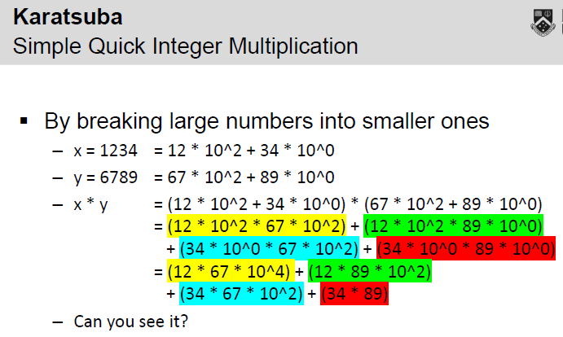

x = ab

y = cd

a: 12 * 10^2 b: 34 * 10^0 c: 67 * 10^2 d: 89 * 10^0

(a + b) * (c + d)

= (a * c) + (a * d) + (b * c) + (b * d)

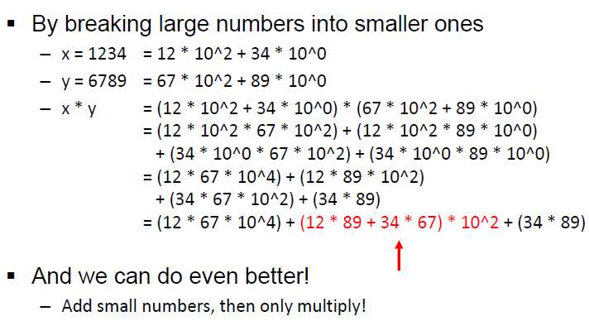

= (a * c) + (a * d + b * c) + (b * d)

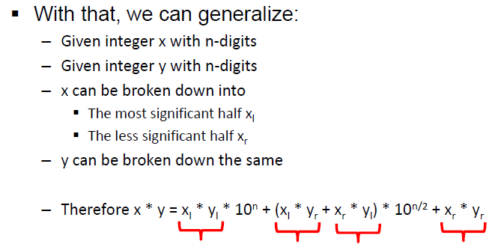

Put 0 at the front of number to make it have equal length at two sides

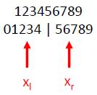

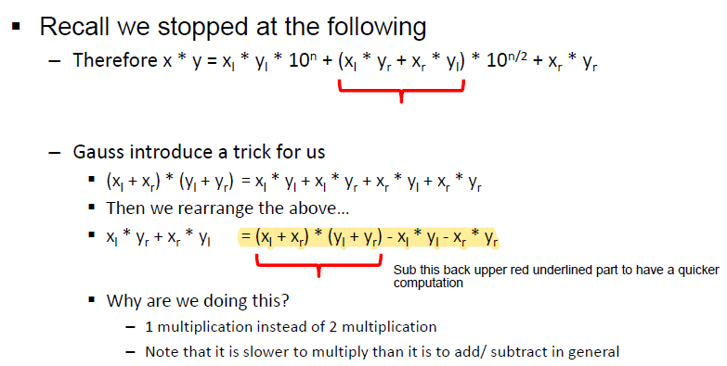

Divide and conquer larger number (x, y) into 2 halved

3 Multiplication are re-used in the following

Compute xl * yl -> i

Compute (xl + xr) * (yl + yl) -> j

Computer (xr * yr) -> k

Original: x * y = i * 10^n + j * 10^(n/2) + k

Since

j = xl * yl + (xl * yr + xr * yl) + (xr * yr)

So

(xl * yr + xr * yl) = j - i -k

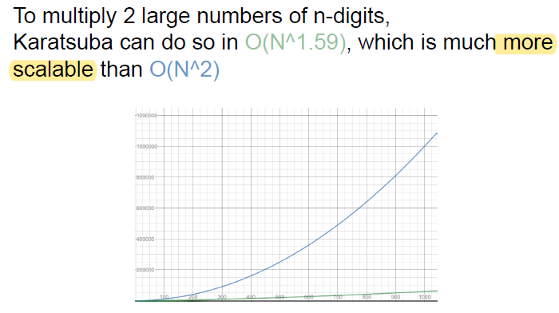

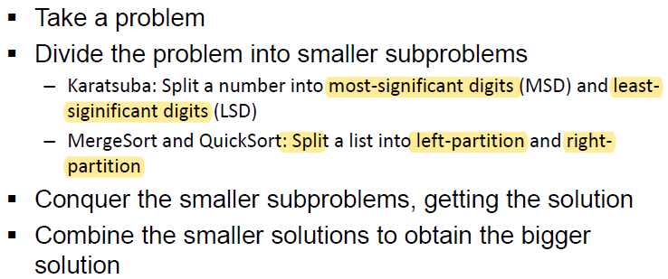

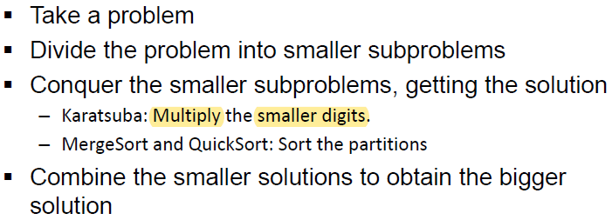

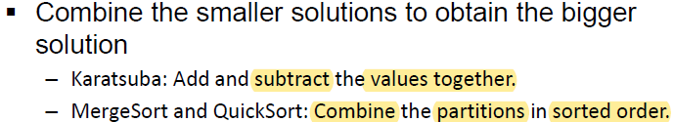

Recurrence Relation:

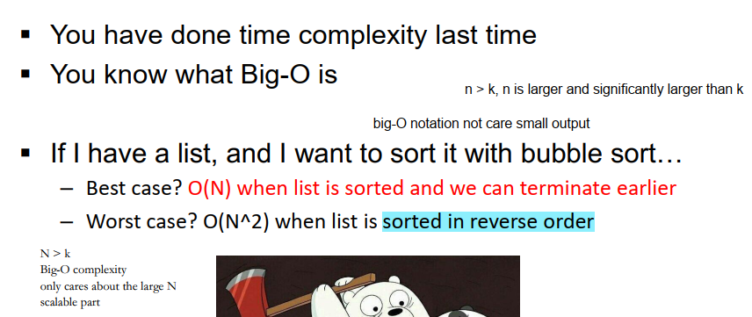

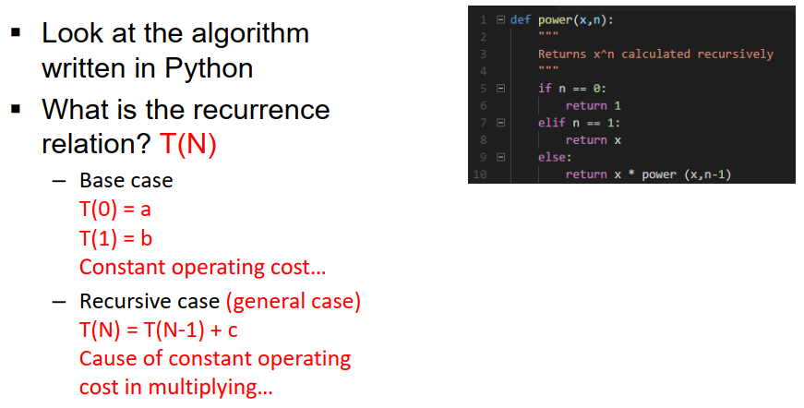

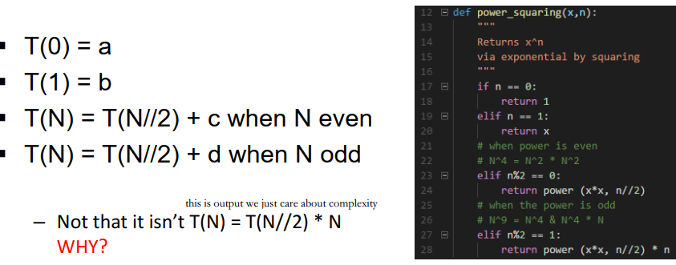

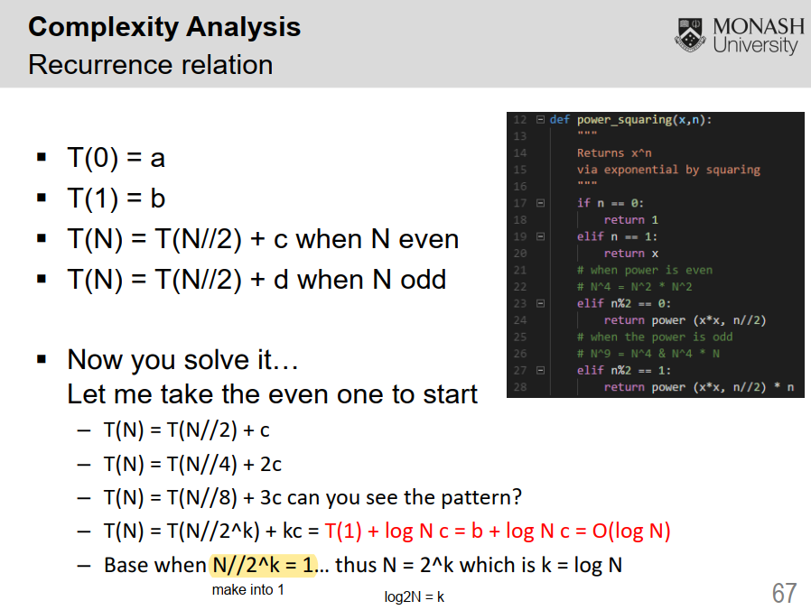

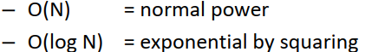

Tut1

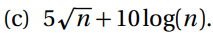



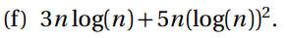

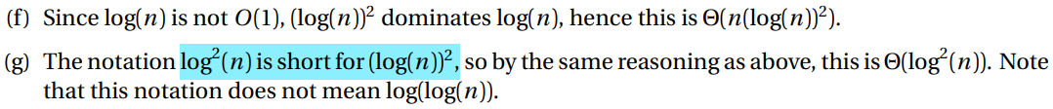

W2

Proof of Correctness with Loop Invariants

- What is invariant?

- What doesn't change

- What is loop invariant?

- Doesn't change every iteration

- Contribute towards your solution/ output

- Link purpose function

- Where can it be?

- Start of loop

- End of loop

- LOOP, not entire function

- How does it work? Proof

- Initiation

- Maintenance

- Termination

Recap of sorting

- Time complexity

- the number of comparison.

- the item in the list.

- sorted

- min vs max or distribution

- the number of swaps. but you realize swap <= comparison

- Space complexity

- input list

- recursive stack

- Stability

- bubble. yes/ no. why?

- insertion

- selection

- merge. yes. why?

- quick. no. why?

- heap. no.

- Do the item in list matter?

- list of N items, the biggest item is M

- M digits if integer in base-b

- M characters if string

- Space complexity: O(NM)

- Comparison cost

- if list[i] > list[i+1] is actually O(M) because comparing list[i] and list[i+1] will go through all characters there

- Let us explore the above using all of the sorts that we know before FIT2004.

- bubble

- best O(N) when list sorted, because we have N number of comparison. But each comparison is O(M) therefore it is O(NM)

- worst O(N^2) when list is sorted in reverse. O(N^2 * M)

- insertion

- selection

- merge

- quick

- heap

- ^ comparison-based sort worst case

- lower bound O(M * N log N)

- list N items = 1,000,000 items

- biggest item is M = 1,000

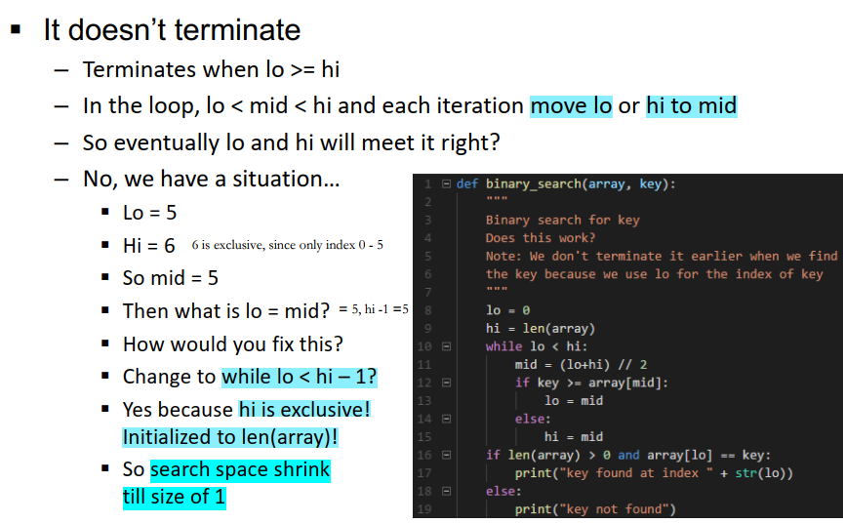

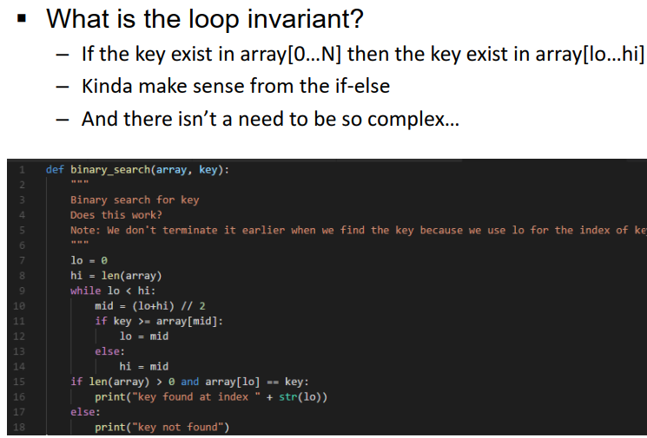

Complexity

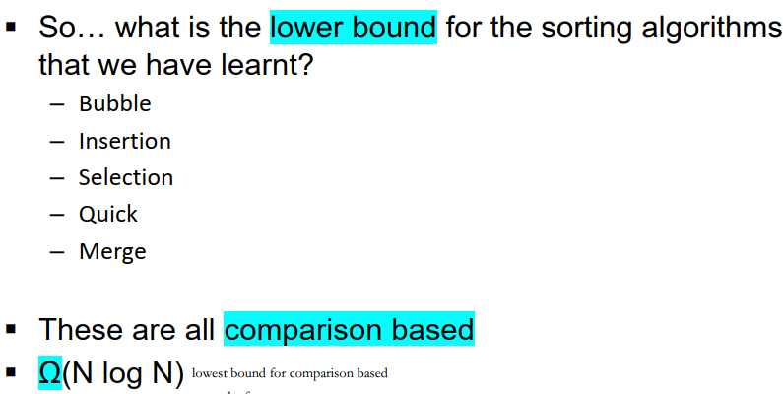

Output-sensitive

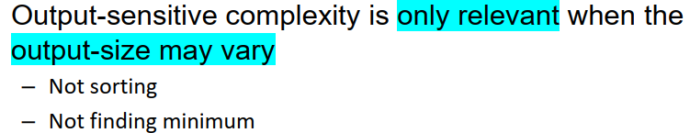

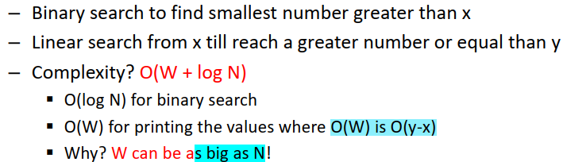\

Space-complexity

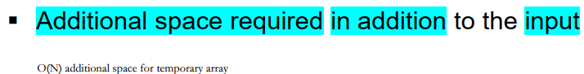

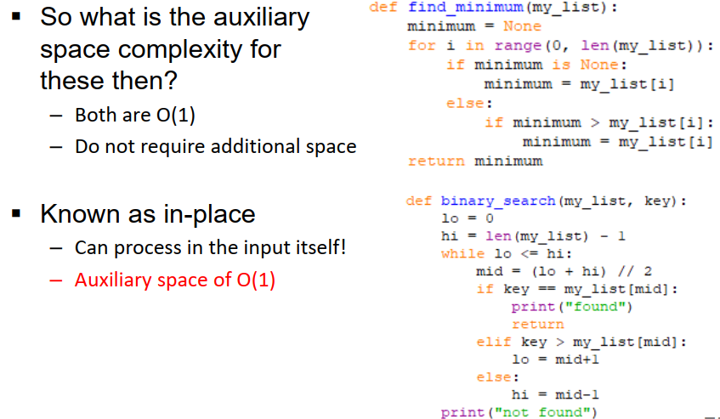

In-place algorithm: algorithm run with auxiliary space of O(1)

Tut2

Master Theorem

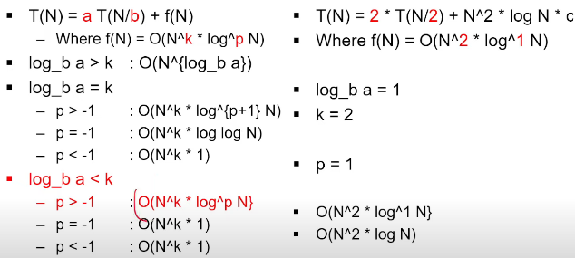

b = log N, then N = b^1

blogb

 log_a b = log_n a / log_n b

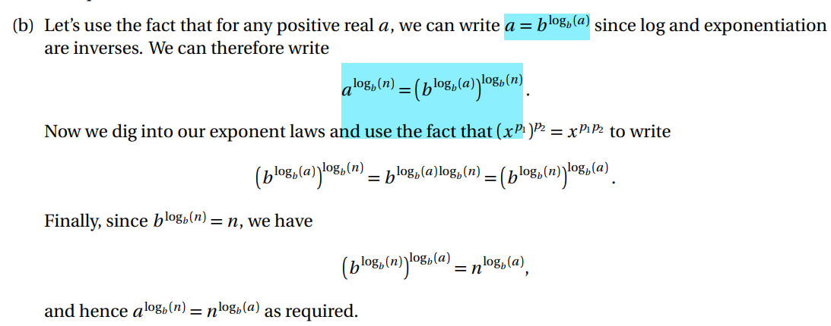

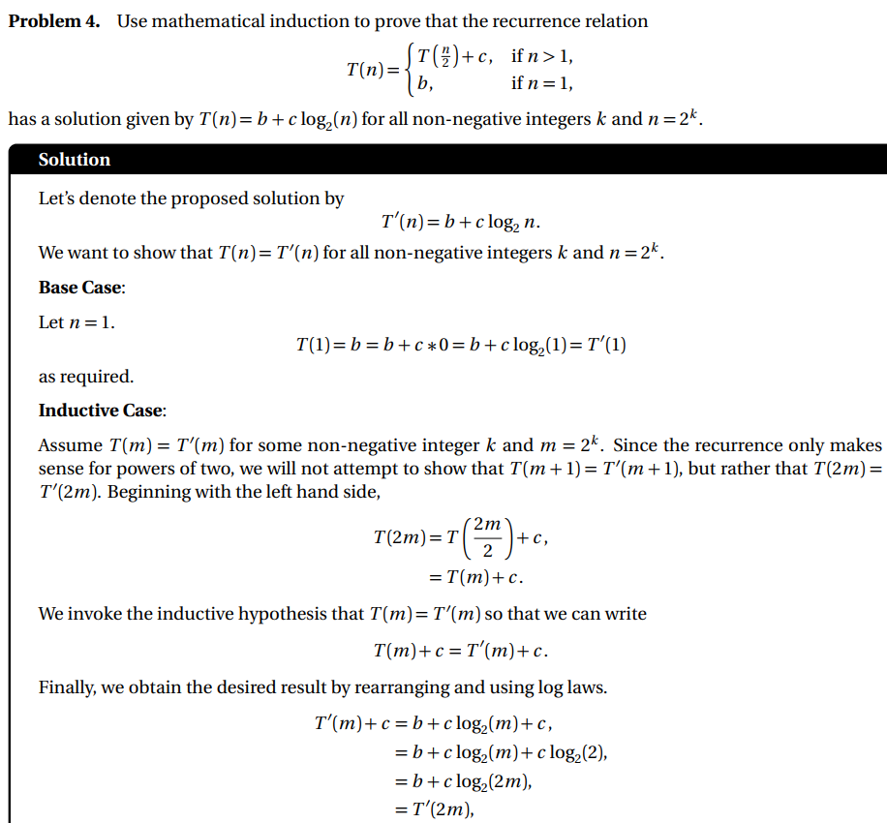

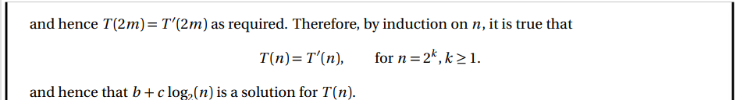



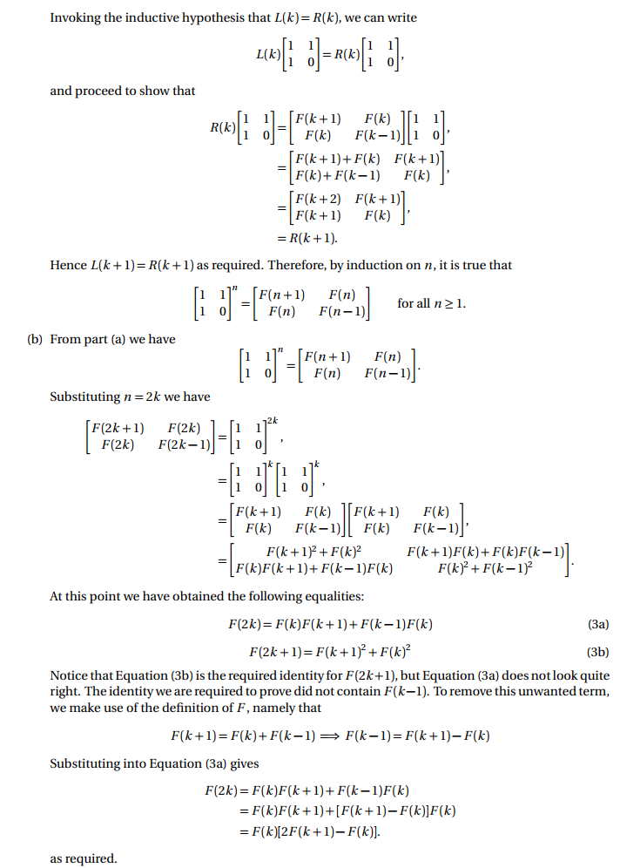

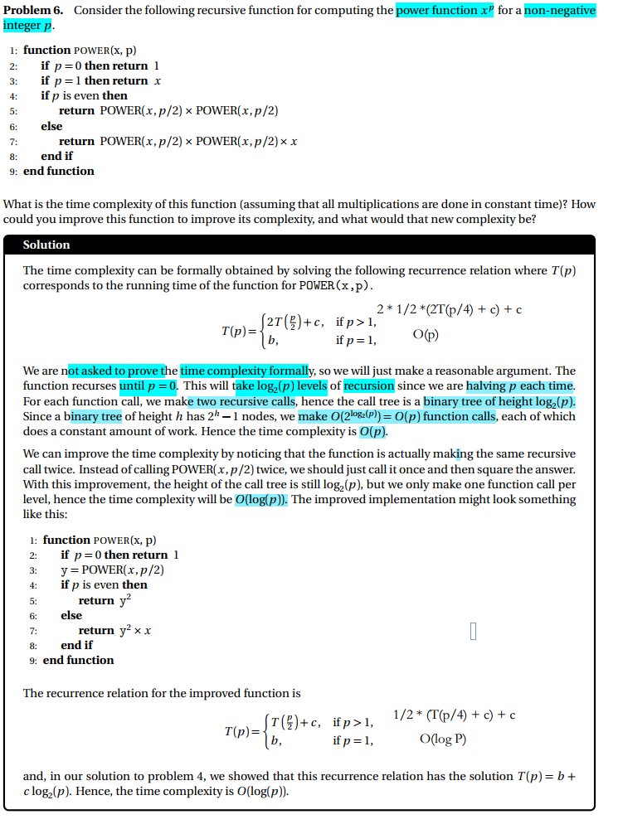

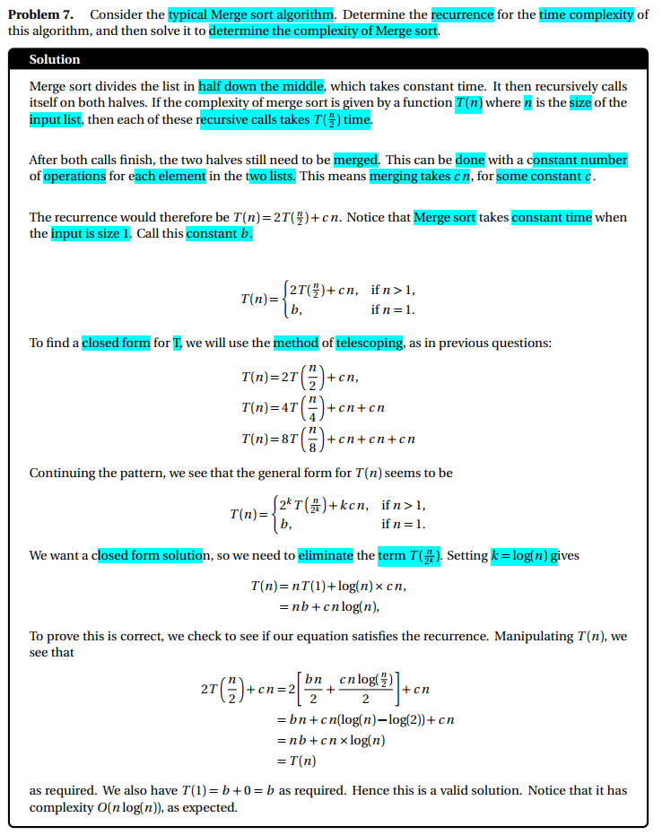



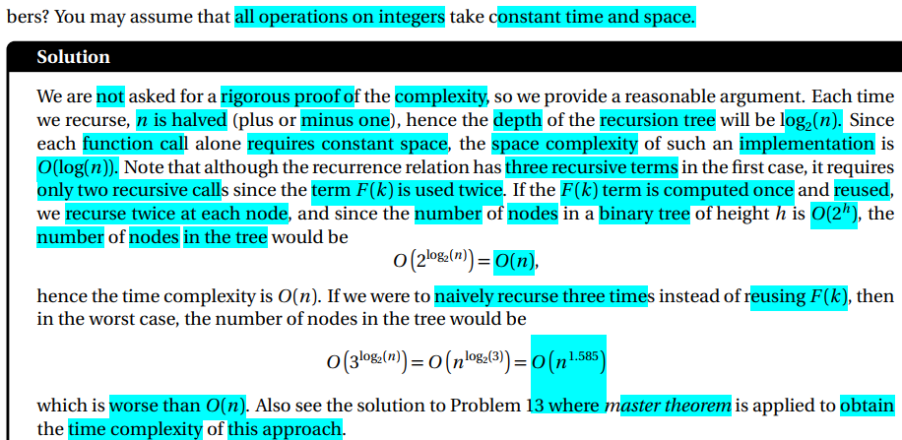

W3_Pass

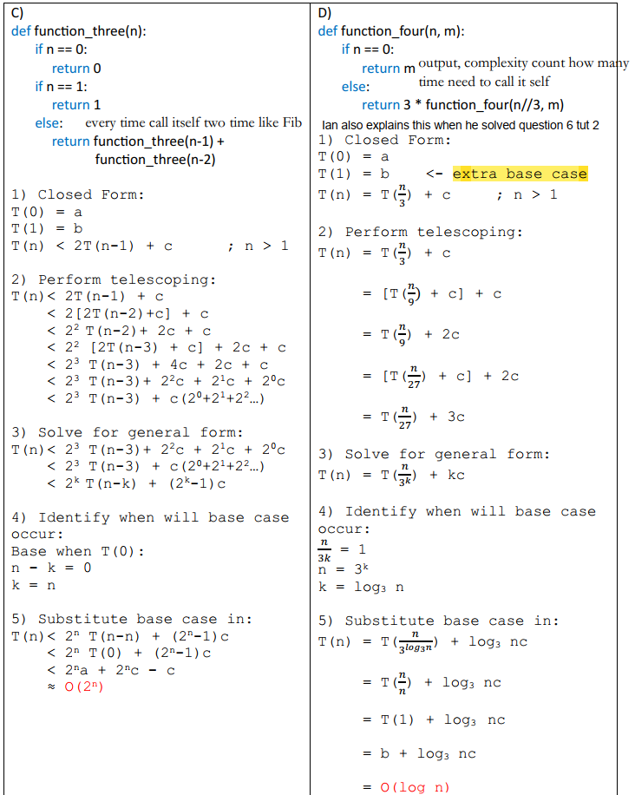

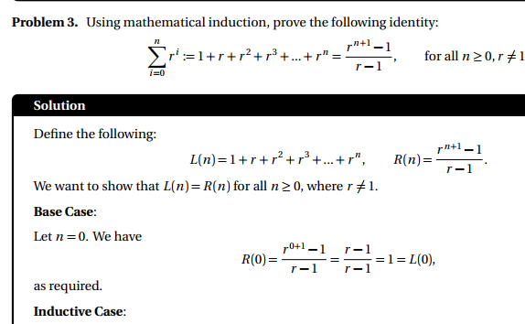

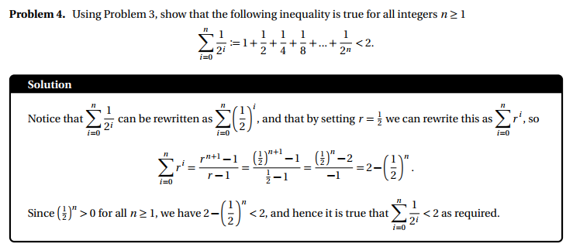

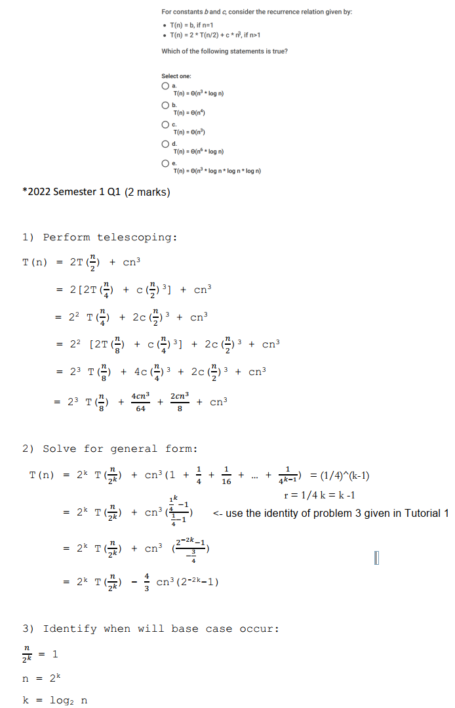

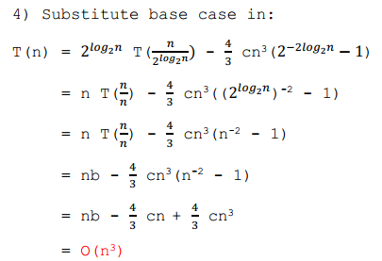

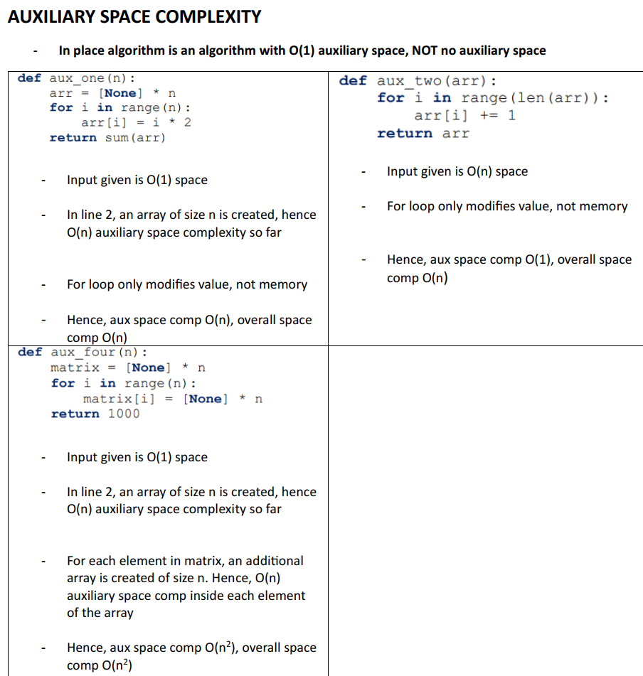

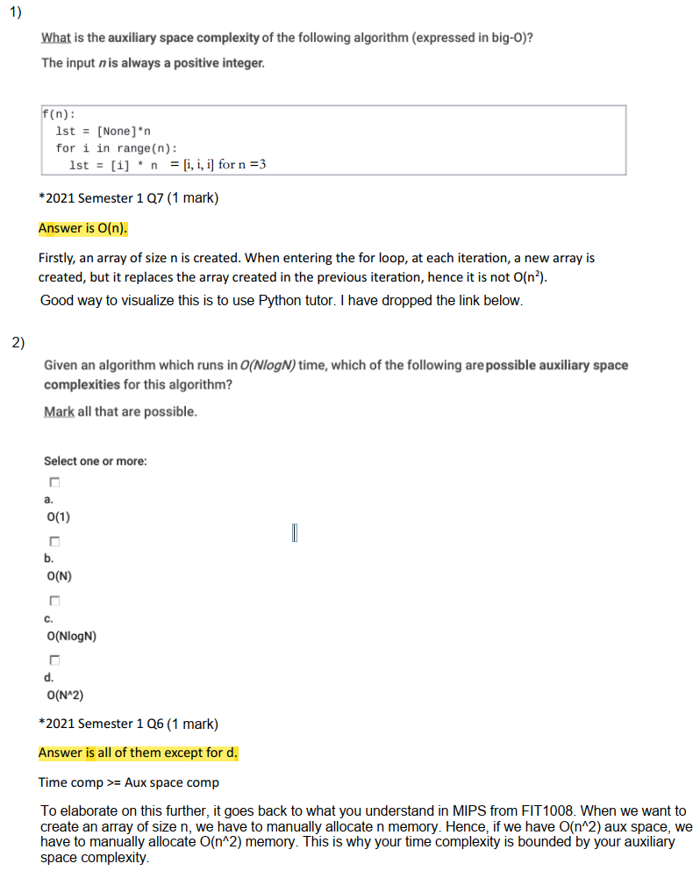

W4-Pass Invariant

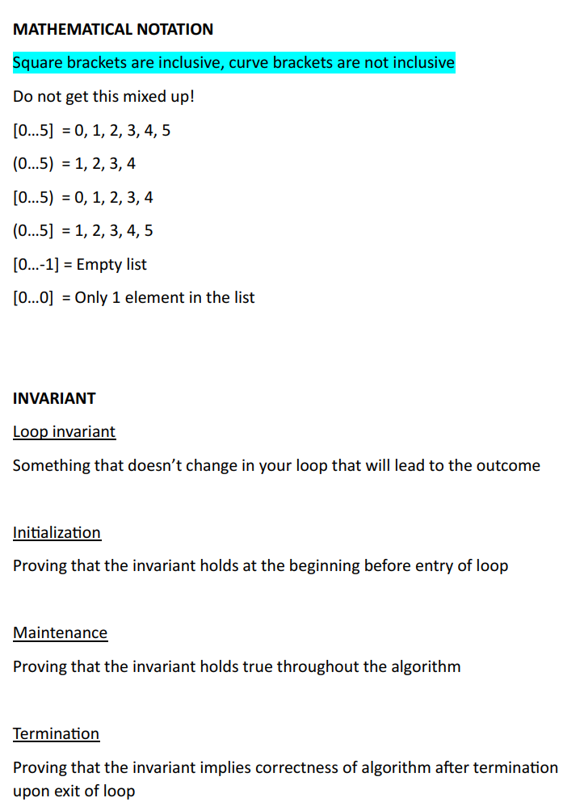

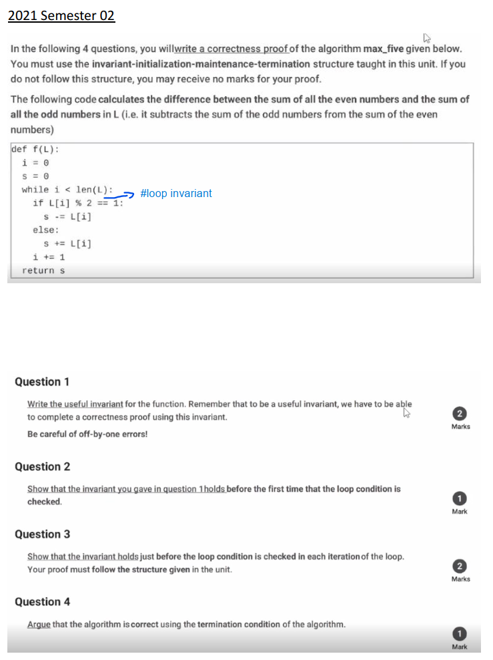

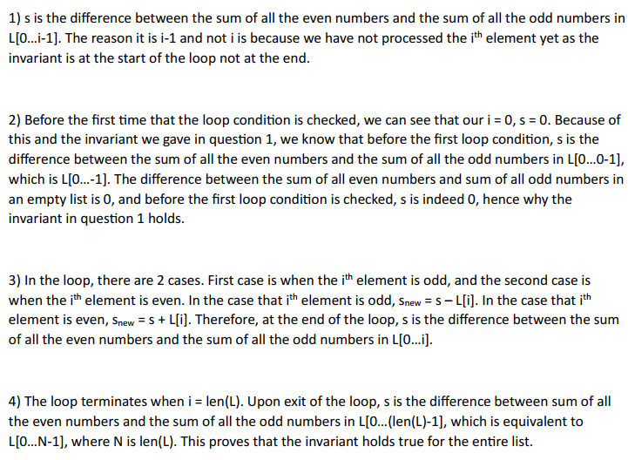

Different end due to while I < len(L)

Len(L) = N

N – 1 = n

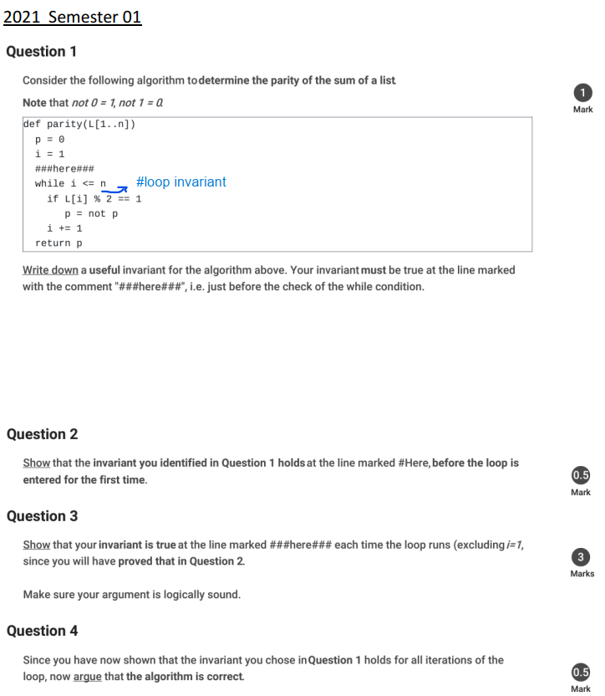

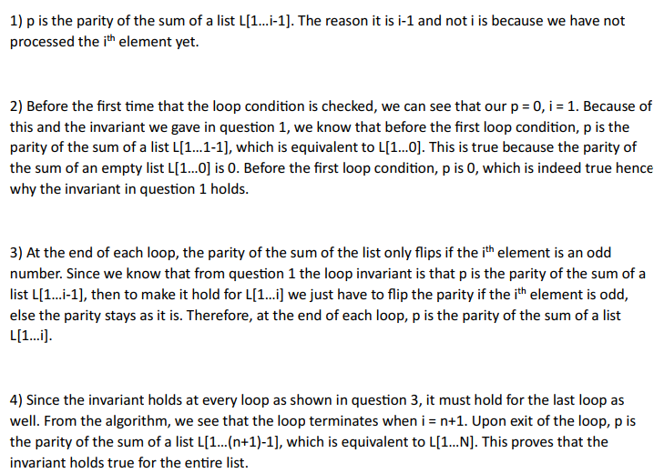

Different end due to while i <= n (n is inclusive)

Selection-sort – not stable

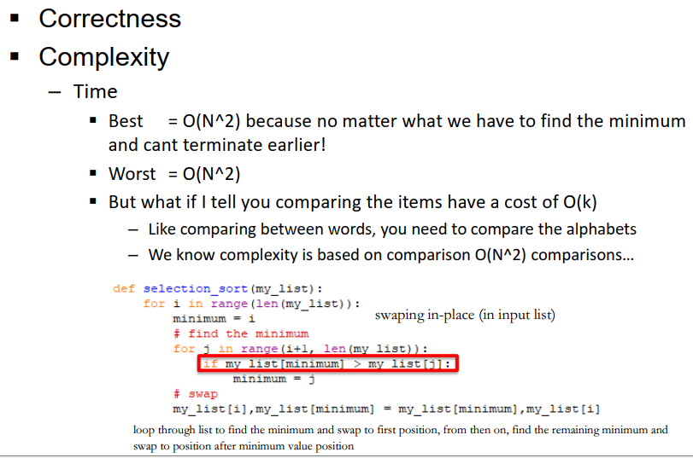

Insertion sort

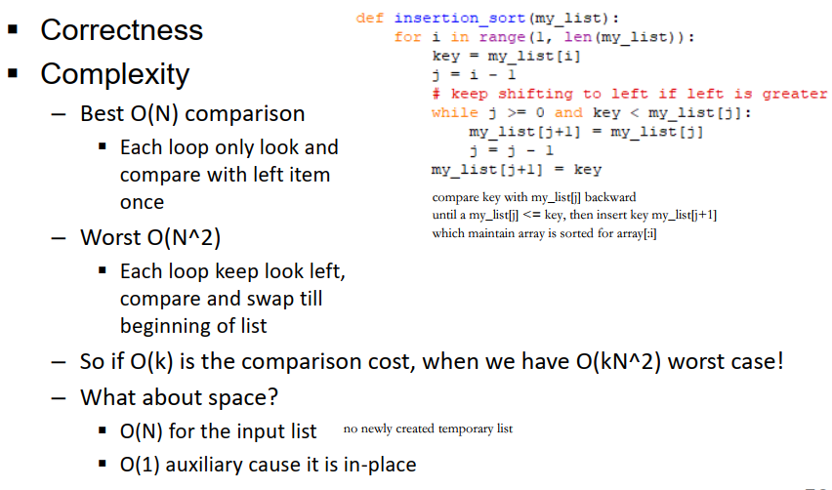

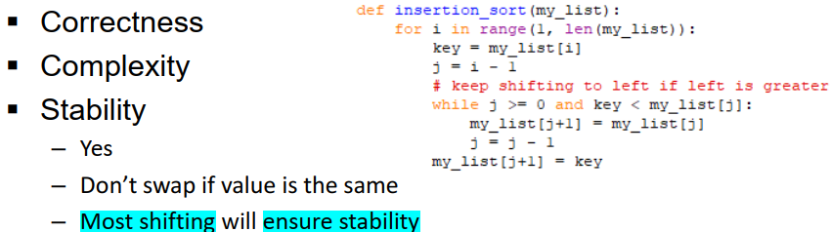

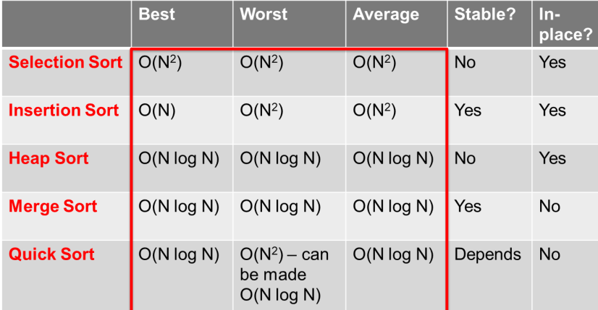

Aux-Recursion (Always No in-place)

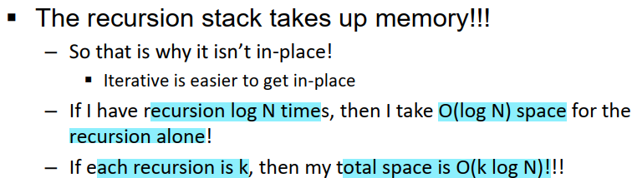

Counting sort (Space complexity – O(M+N)

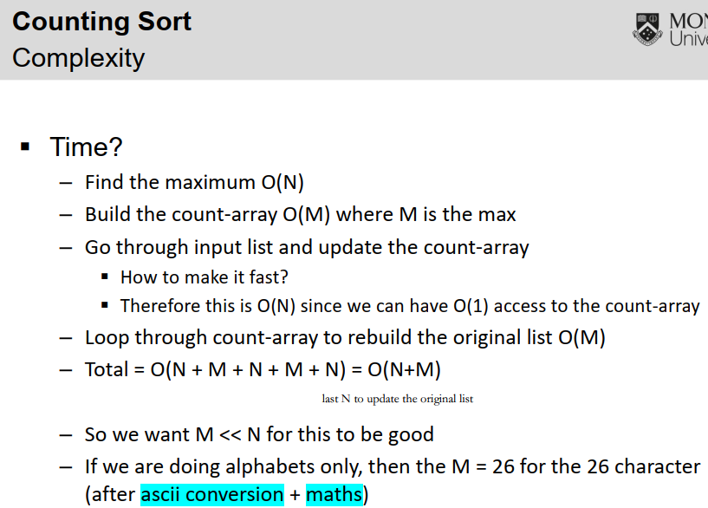

Counting Sort- Problem: Standard one is not stable

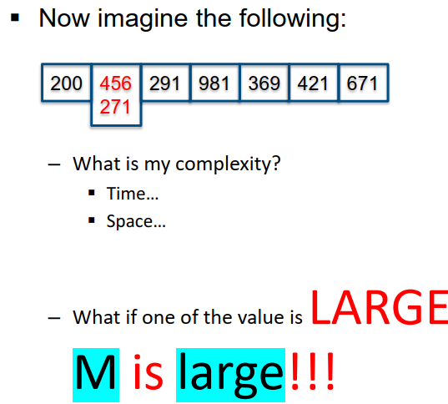

Stable Counting Sort

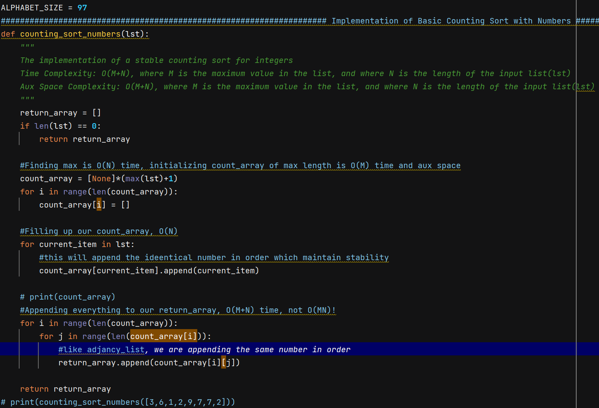

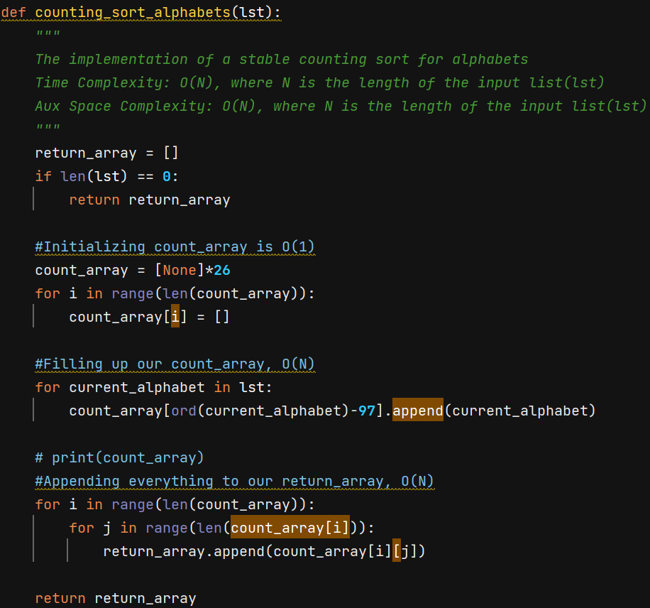

Count_array[i] = [] ([None])

By making each array in Count_array to have separate memory address as separate list

Radix_Sort – respectively applying counting sort on digit from least significant bit and most significant bit (overall multiple time of applying counting sort on all number)

Require counting sort to be stable

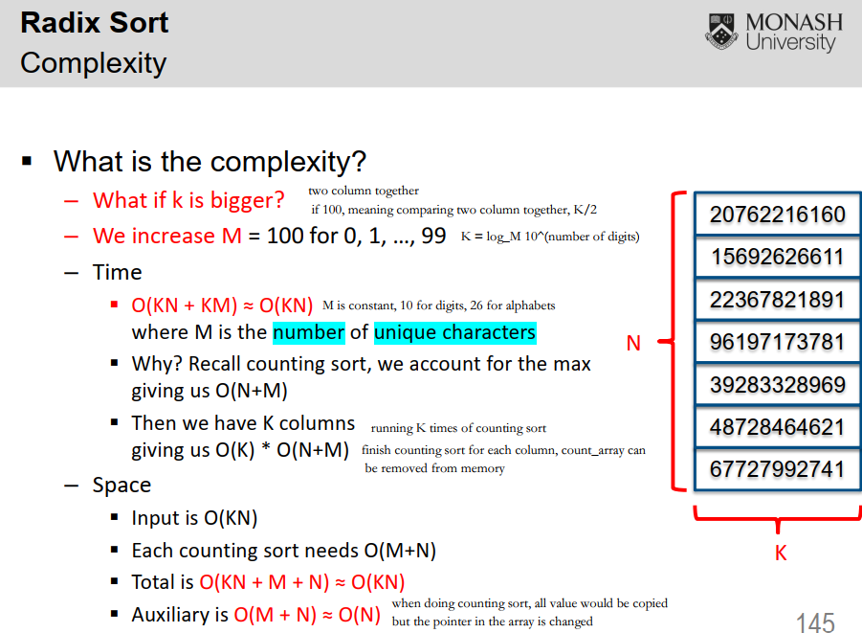

Number of columns = log_ base M, M = biggest item (M digits)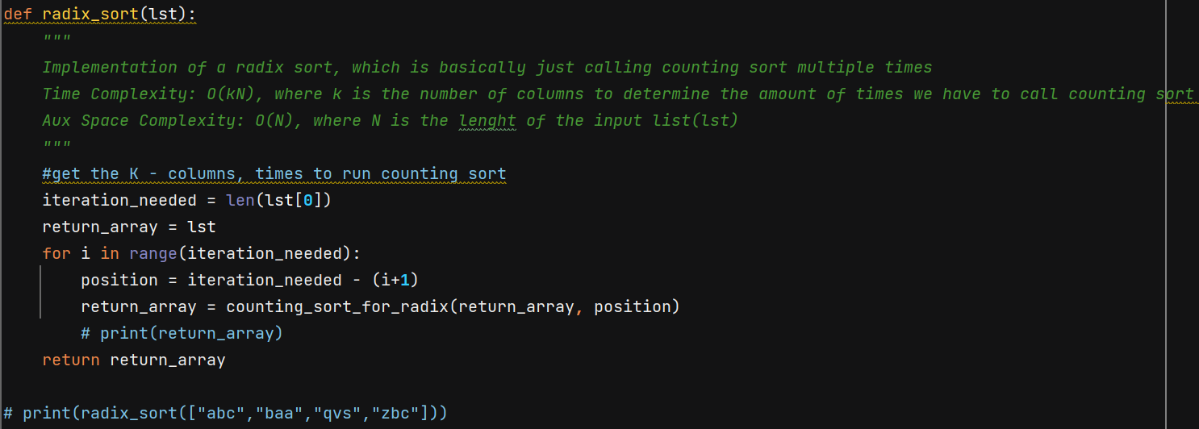

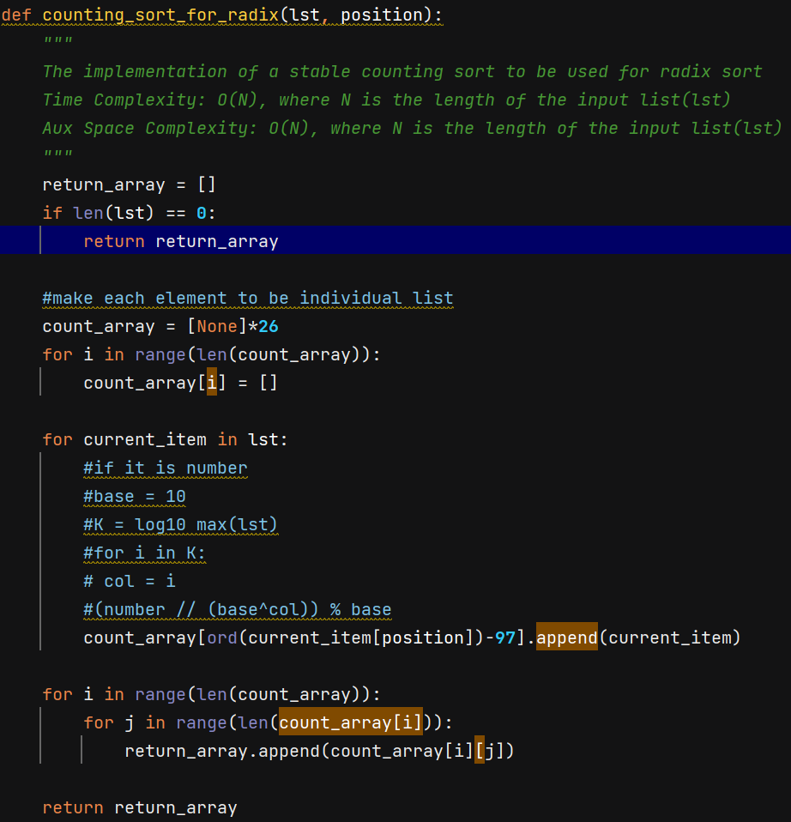

W3

Quicksort (Not in-place due to recursion, probably has less input every time)

a*logb(x) = logb(x^a)

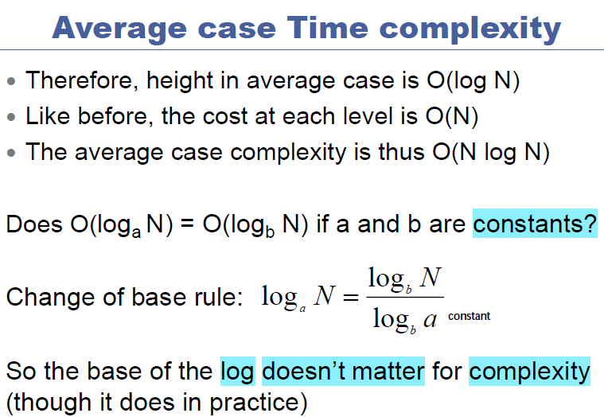

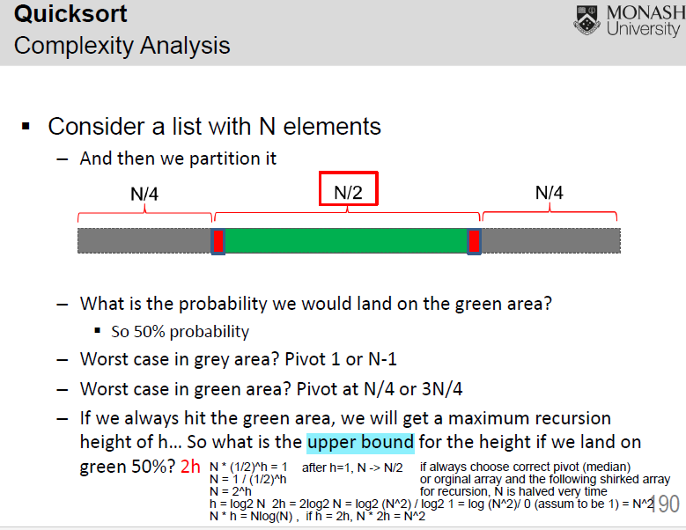

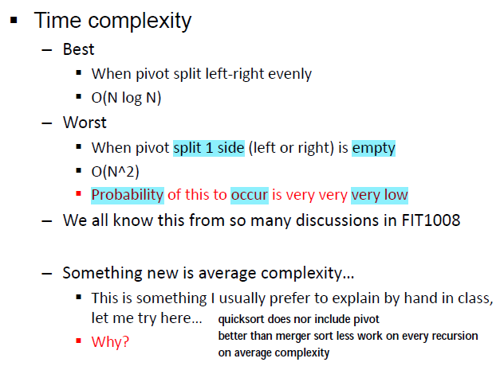

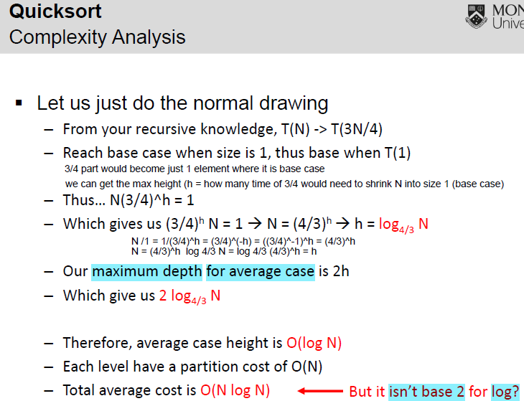

Quick with random pivot

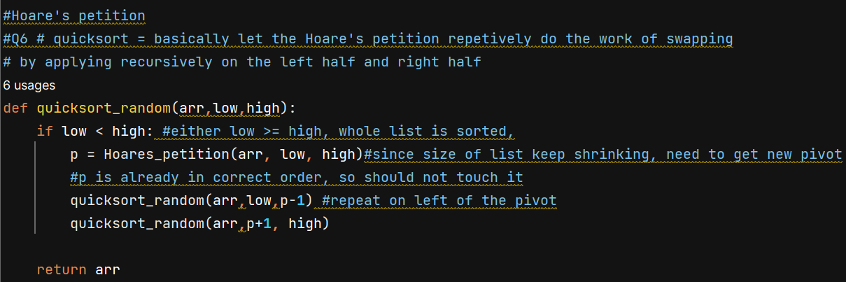

Partition:

Hoare’s :

The final swapping of the pivot from 1 st position to R_bad would mess

up the stability

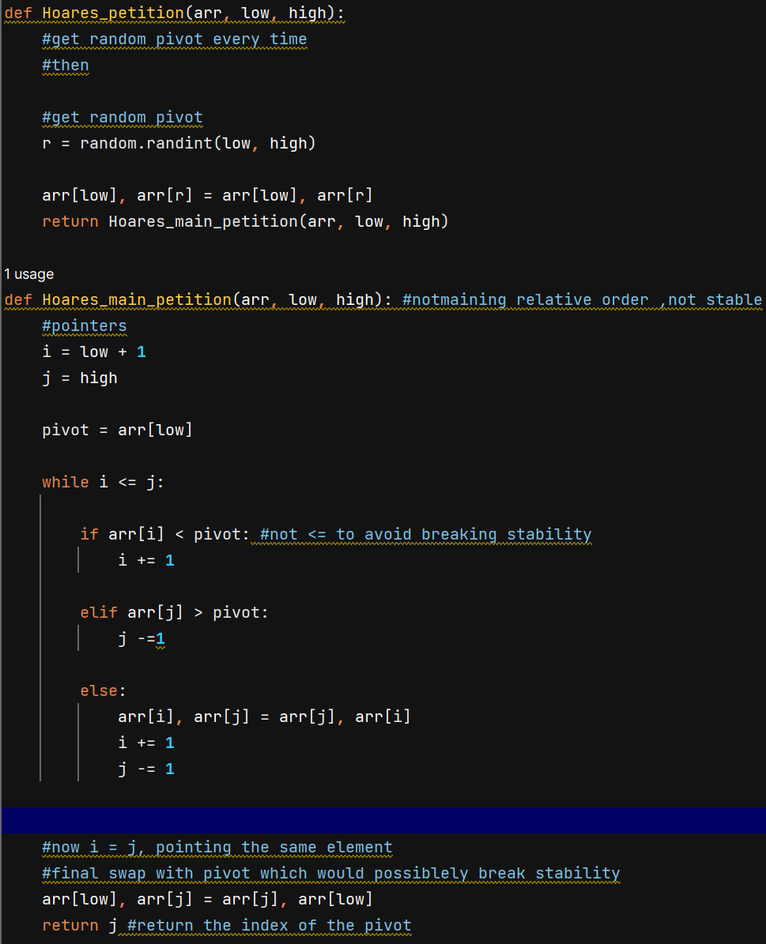

Lomuto’:

Swap each element multiple times

Just Shrink from size into 2(pivot = arr[high], I = low), just sort these two

And do it recursively 2 -> 4 -> 8,… pivot change since the high of arr change

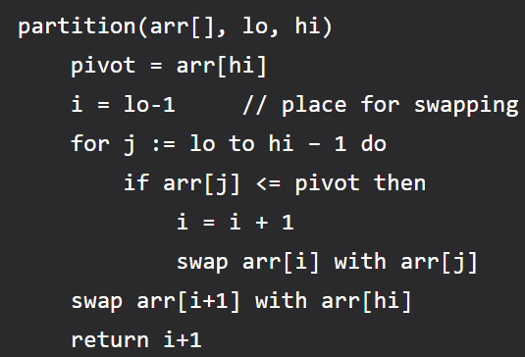

Worse than Hoare’s

… and still unstable

Dutch National Flag

Maintain stability

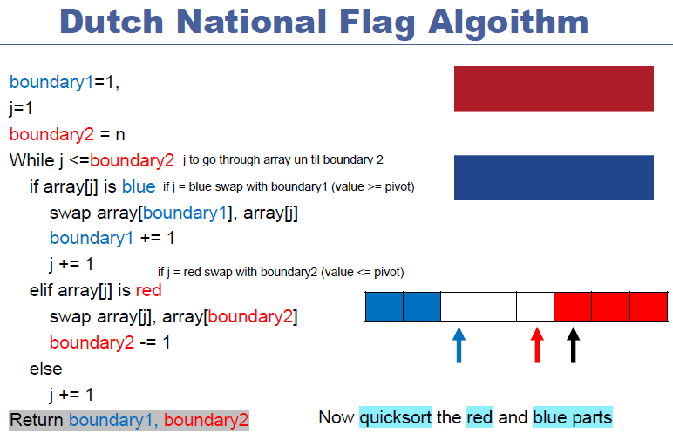

QuickSelect

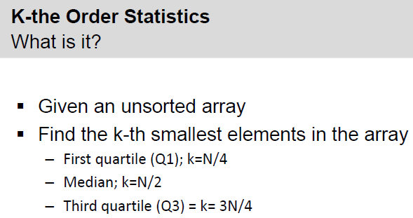

Complexity:

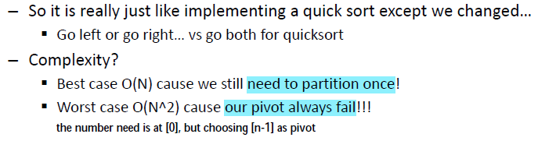

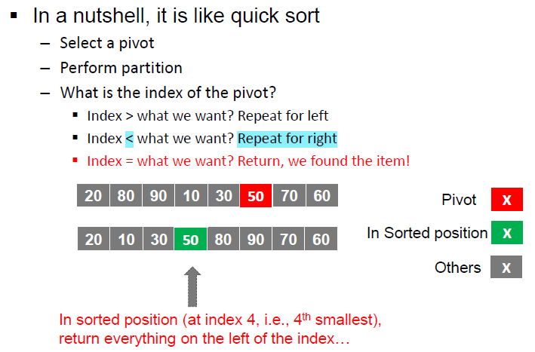

Quick with QuickSelect

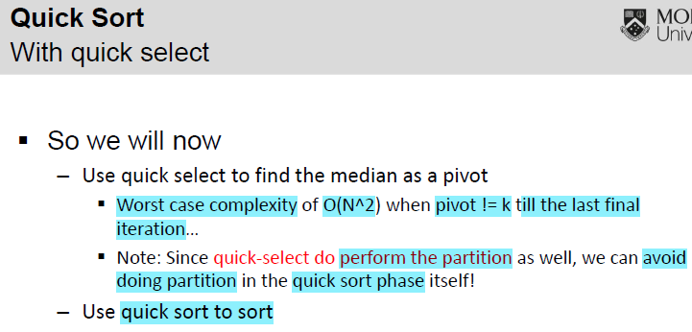

Quickselect give a good pivot

Quick Sort with Quick select = Quick sort with good pivot

Complexity: O(N^2)

Since Quick select also need good pivot

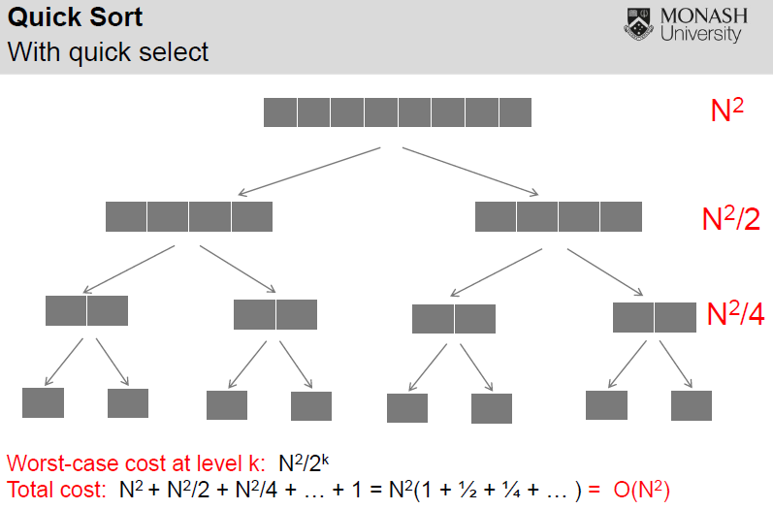

Use median of median

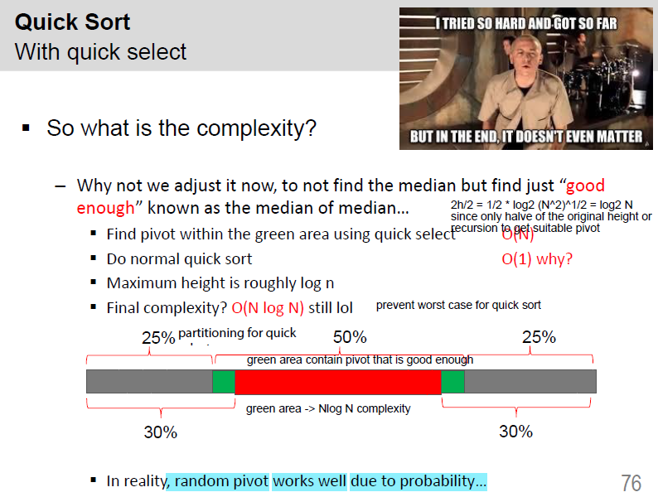

O(N) – complexity of Quick Select

Just petition can already get the good enough pivot in green area

Look at Last swap of Hoare’s petition

Arr[j] must be in the green area, since j index is always in the middle of array

Nlog2 N – complexity of Quick Sort with good pivot

Petition – log2 N

N times (N, N-1, N-2,…)

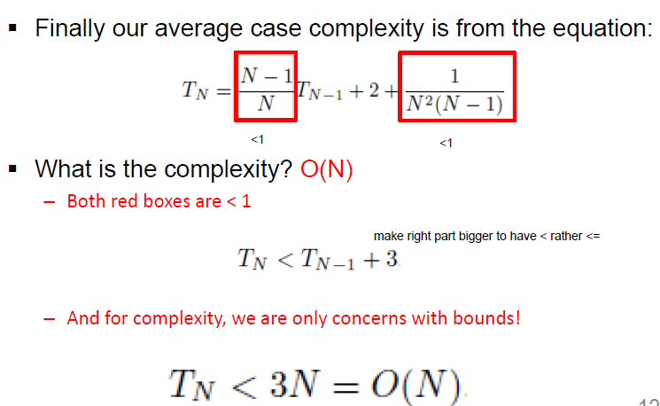

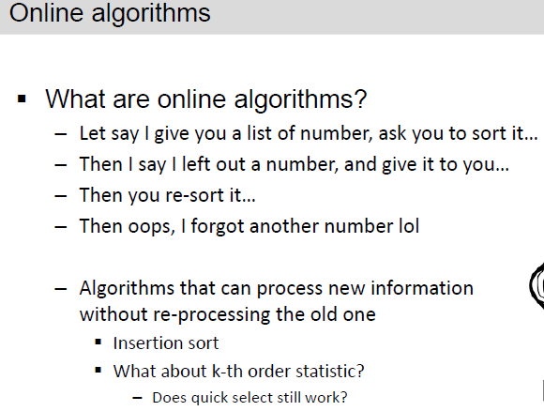

Merge sort and Quick sort, Bubble sort can not process with new item within O(1)

So off-line algorithms

Normal Quick select not online

Can work with modification

K to get k-th smallest values

Recursively use petition, until the k = pivot

Since value at pivot would be in sorted position after every petition

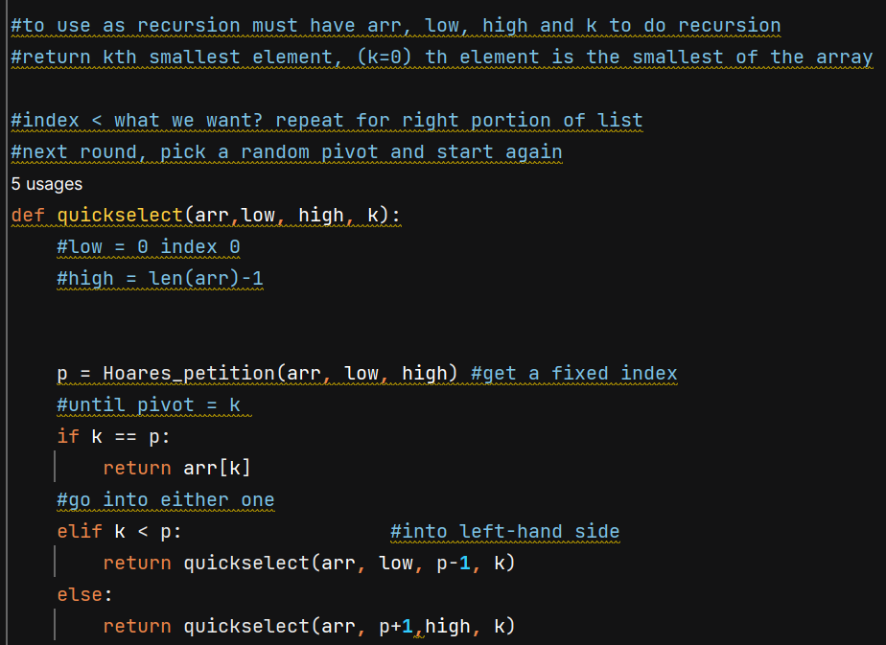

Tut3 – not finished

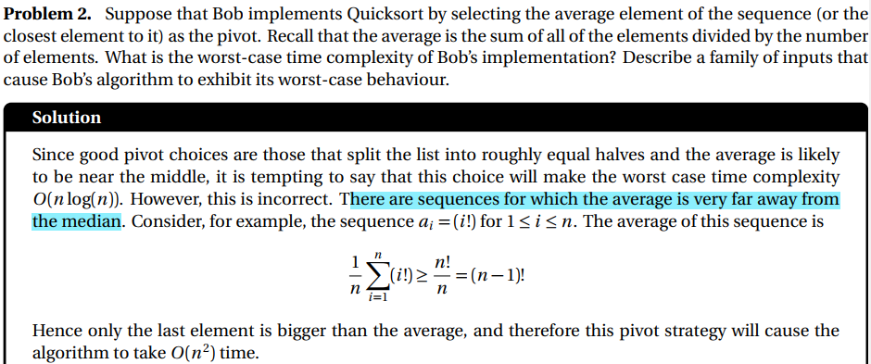

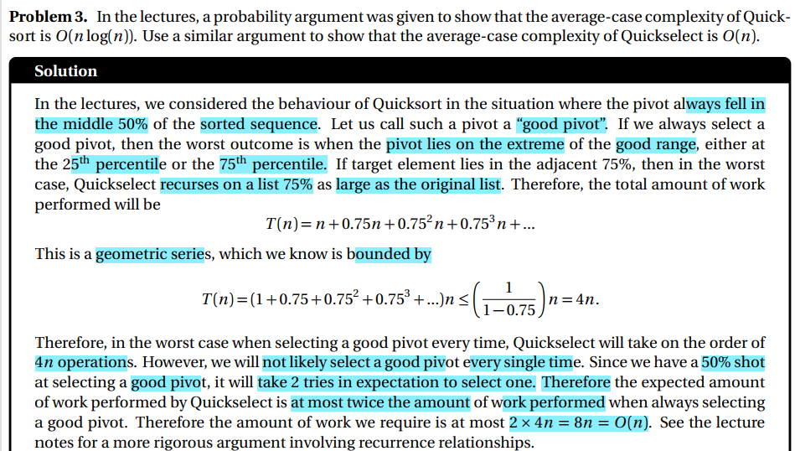

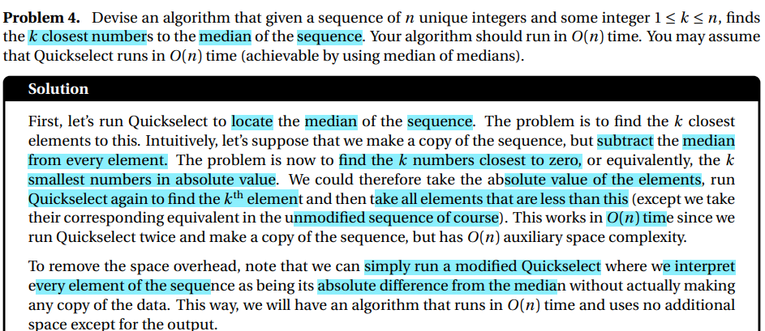

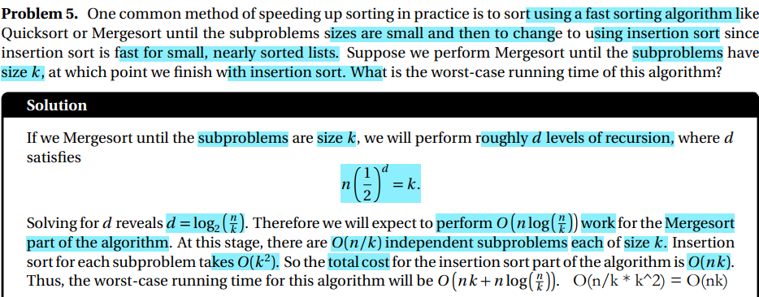

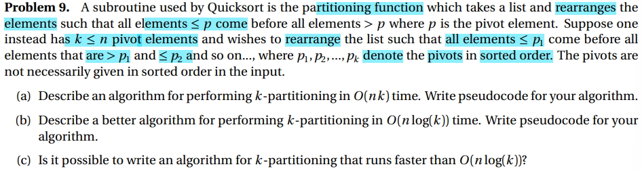

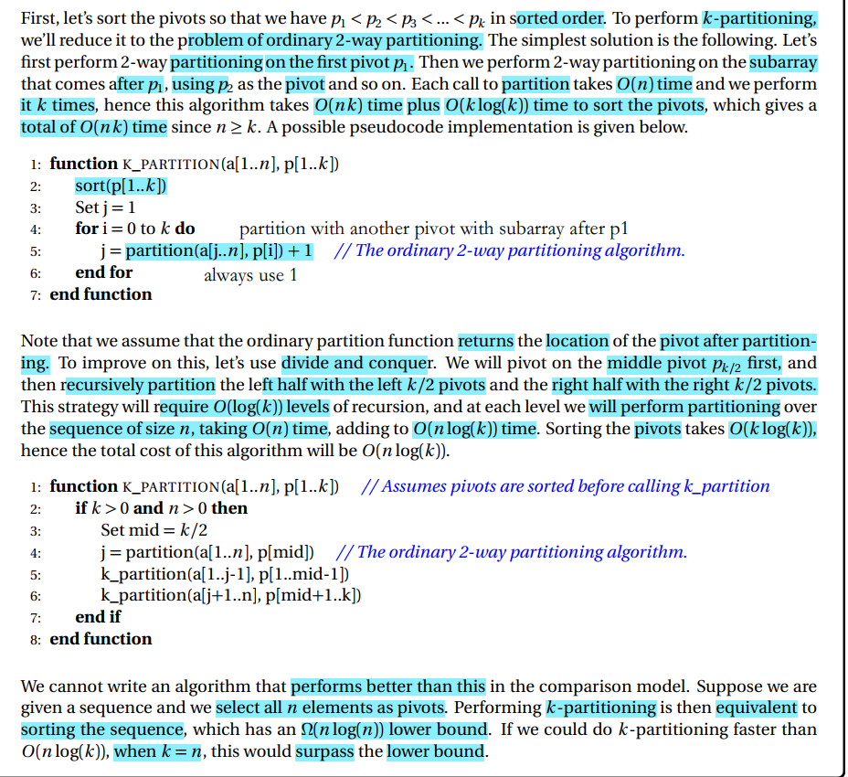

W5

# Week05 Agenda

Graph Data Structure

- Vertex, O(V)

- Any extra information? Coding?

- Edge, O(E)

- Relationship connecting entities

- E = O(V^2)

- Directed graph

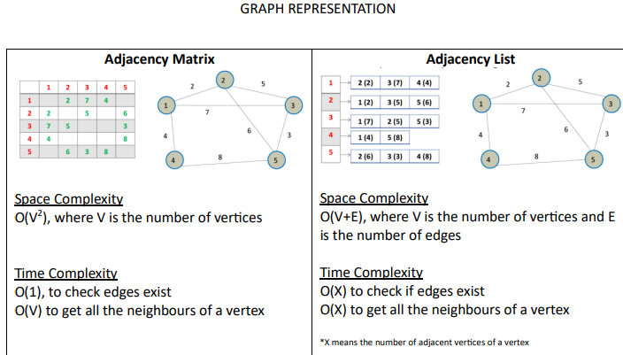

Matrix with V rows and V columns, has edge id as value

O(1) to see if there is a edge between this id to anther specific vertex id

O(V) in a specific row loop through all columns (see there is a value(edge))

List: list of neighbour vertices for specific vertex (edge in between)

Traversal

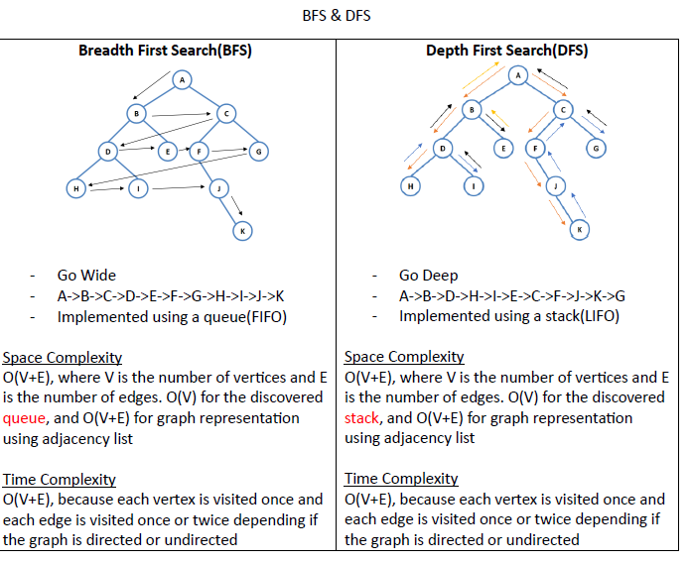

BFS is specialised for shortest (shortest cycle), can go layer by layer

DFS is specialised for longest (longest path or cycle), can go dive in

Dijkstra = BFS + Minheap first distance; 0….+inf

Minheap priories the edge with distance closer to 0

Deque (work like Minheap) for distance 0, 1

Prepend 0 (prepend – add to the front)

Append 1 (add to the end)

To prioritize edge with distance 0

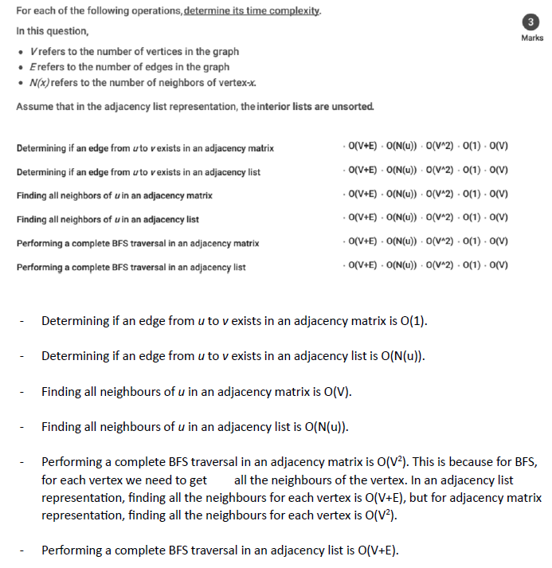

O(V^2) BFS in matrix would probably run through every vertex column for every vertex row

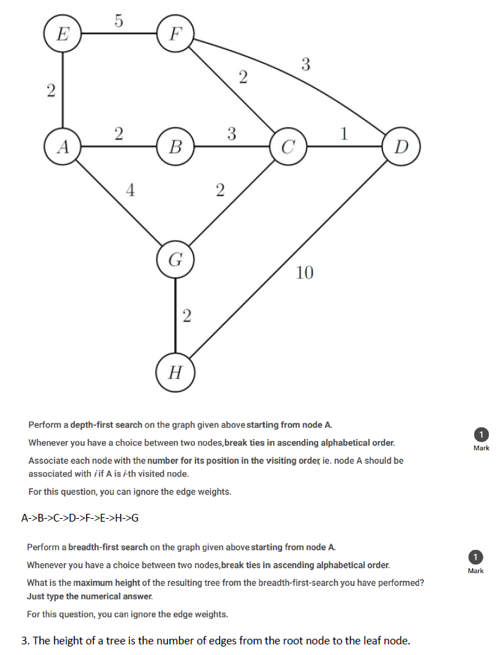

Break ties in ascending alphabetical order – if multiple options choose the one Lexi graphically smaller

DFS: once found one, just go straight into it (if v.visited == False next_dfs = self.def_self(v.id) , not need stack for checking discovered, see dfs_self function in bfs_dfs py file)

A -> B -> C -> D - > F - > E (no non-visited vertex), (backtrack to the vertex that has next_dfs by recursion D) -> H -> G

BFS

A is the root node, D is the leaf node, height of a tree is the number of edges from A to D: 3

**DAG Directed Acyclic Graph**

* Directed, No cycyle
* Directed edge from A to B, need A before B (since no cycle, no coming back)

Topological sort

A is ordered before B in DAG

* This enable us to sort a DAG

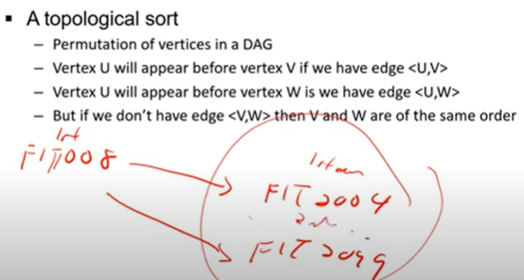

U must before V if has edge <U,V>

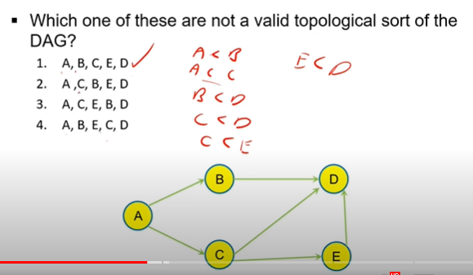

- Kahn's (which is a modified BFS) O(V+E) = O(BFS)

1. Take BFS: add un-discovered vertex into queue

2. Modified BFS: add in vertex to queue that has no incoming edge (prerequisite) to find topological sort (if it is a DAG)

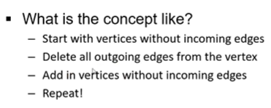

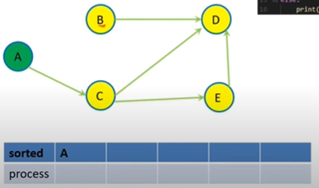

Add A, serve A, search available vertex B in one of the outgoing edge. Remove outgoing edge from graph, if B has not more incoming edge, add B into queue. Repeat for other vertices (c in this case) as v outgoing edge of A

Create incoming_edge array with index = vertex_id, to store number of incoming edges to that vertex in the array[vertex_id]

Cycle !!! Not DAG !!!!

If after doing the Kahn’s algorithm, value > 0 in array (still has edge in graph)

There is some cycle in DGA

- Modified DFS

1 Modify DFS to find topological sort (if it is a DAG)

Use DFS-recursion (LIFO) plus stack (LIFO)

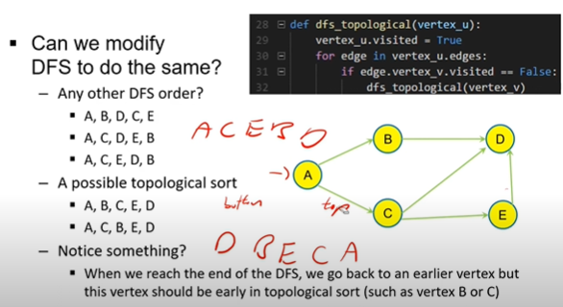

DFS until the vertex that no outgoing edge

Add vertex into stack if all outgoing edges are traversed (D in this case, lowest priority one)

Backtrack to B, <B,D> edge is traversed since D is already in the stack (self.visited = True), so put in B

A can not so go to C, then D, since D is already inside, backtrack to C

Still can not, go to E, then D.

Then add E like B, backtrack to C, add C like B, finally add A

Eventually, use pop() to output it FILO (reversed

**Dijkstra**

- instead of FIFO queue -> priority queue

- Single source shortest distance

- BFS is the single source shortest distance (number of edges)

- Dijkstra is the same but weight of edge

- 2 approach

- Work for negative?

- may work

- may not work

- see negative, dont use dijkstra

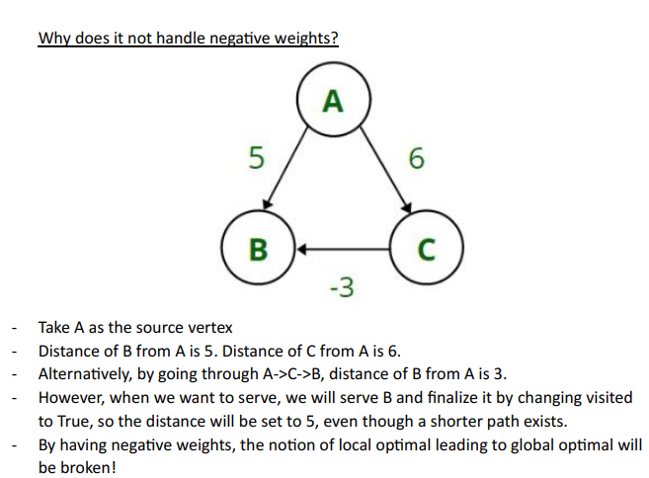

Since Dijkstra relies on the backtracking to reconstruct the path from the source to end, if there is a negative value edge (small positive value still at least increase the overall distance)

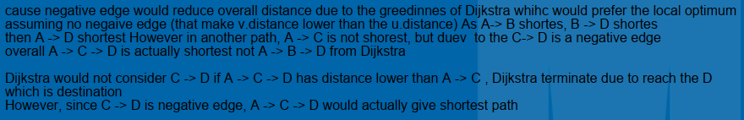

- Complexity

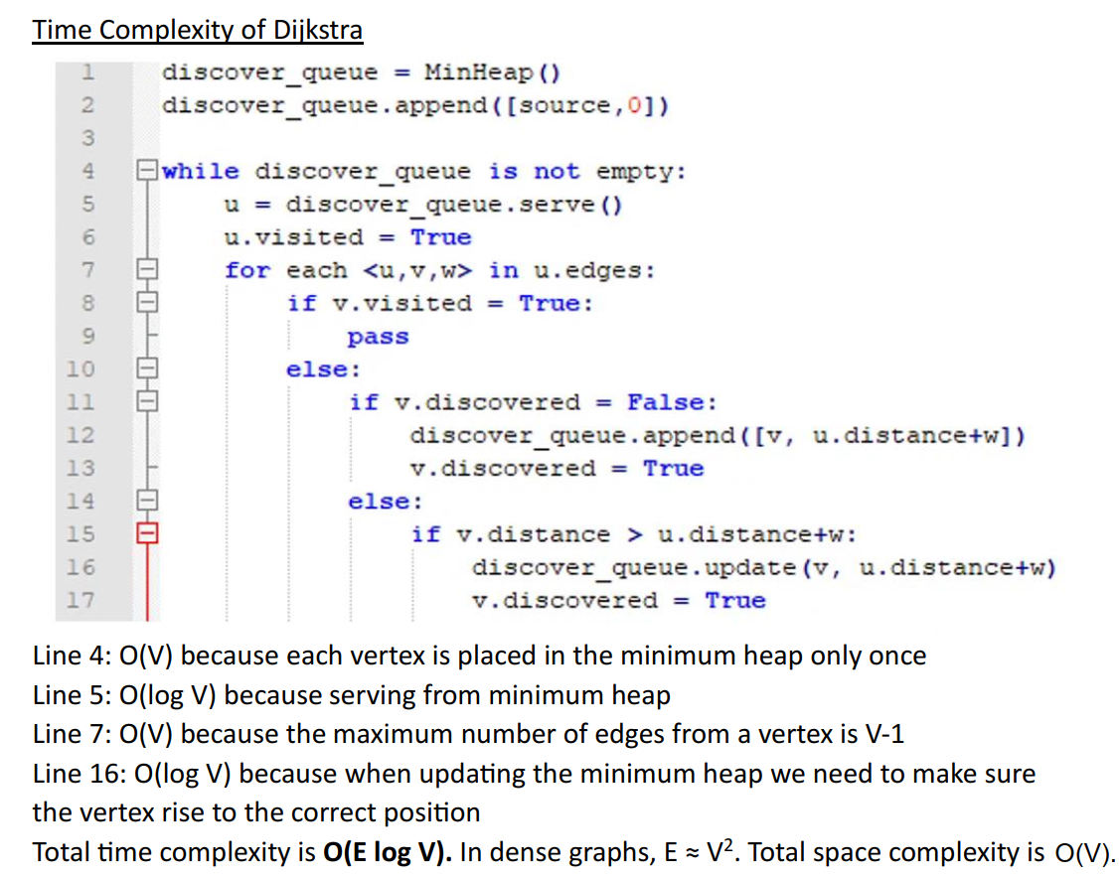

- time = O(V^2 log V) O(E log V) (in dense graph, since E = V^2)

- aux space = O(V)

- Some bonus stuffs

BFS can only +1 every time

Need vertex to store the distance [0…Inf] in the vertex,

=> Dijkstra:

Like using BFS to find the shortest distance path from source to end

Greedy: (Hope to get global optimum by local optimum)

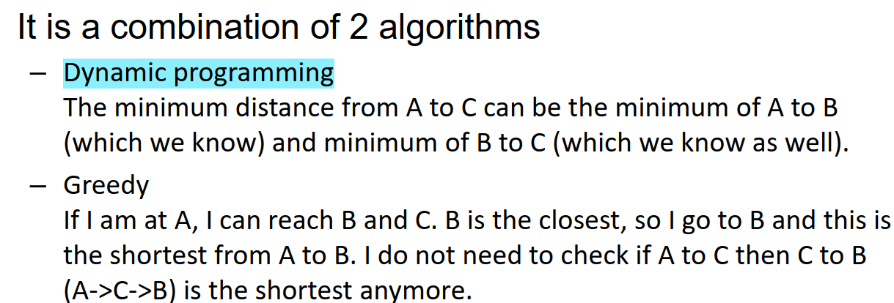

Since not checking C to B in A->C->B due to terminate early, if C->B has negative distance A->C->B would have global optimum.

Procedures:

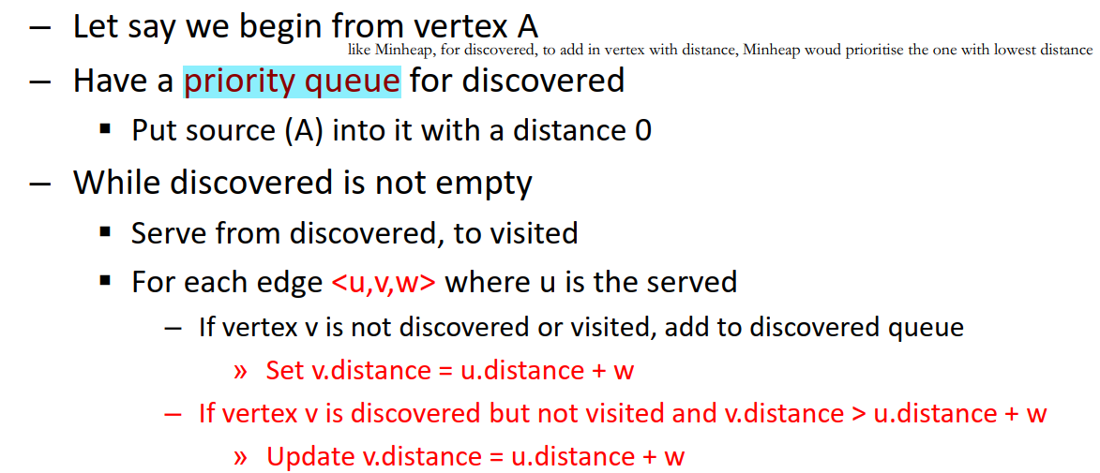

Use v.previous to choose which path to backtrack to source to get the complete path (since multiple path possible from source to end)

Time complexity;

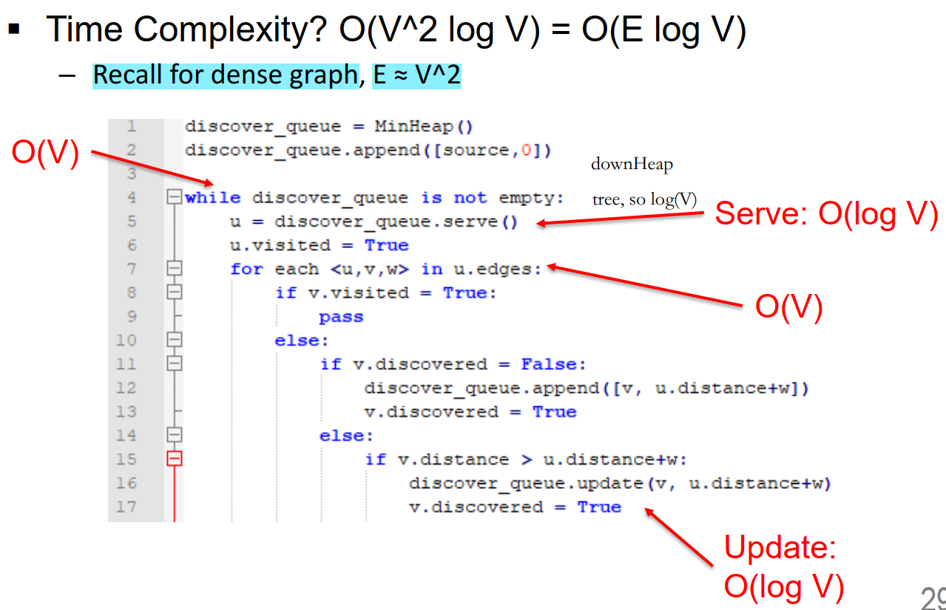

W5

MST

Prim's and Kruskal's for Minimum Spanning Tree

- Graph is UNDIRECTED

- What is MST?

- minimum = sum of weight is minimum

- spanning = connect all vertices

- tree = no cycle

- Why are they Greedy?

- in what way is Dijkstra greedy?

- when a vertex is served from heap, the distance is finalized as the shortest distance

- v.distance = u.distance + e.w

- v.previous = e.u

- in what way is Prim's greedy?

- when a vertex is served from heap, the edge that connect to this vertex is in the MST

- this means edge<u,v> is in the MST

- Prim's

- Just like Dijkstra

- complexity O(E log V) O(V^2 log V)

- edge relaxation, v.distance = e.w

- priority queue (min heap)

- max heap, will you get maximum spanning tree? YES

- if it is minheap, and u negate the polarity, you also get maximum spanning tree

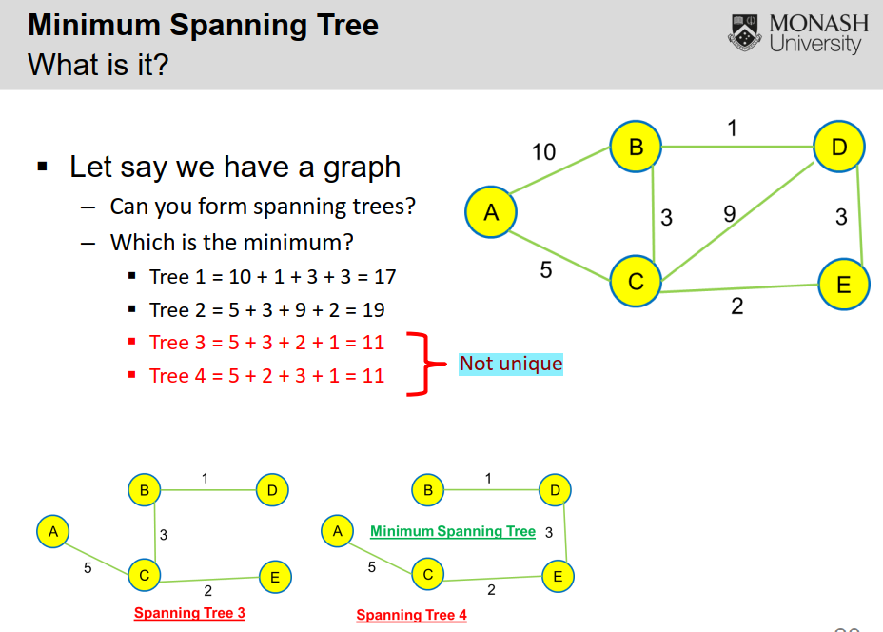

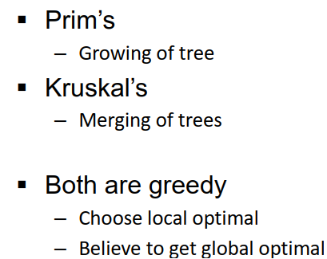

Prim’s – Prim’s Dijkstra

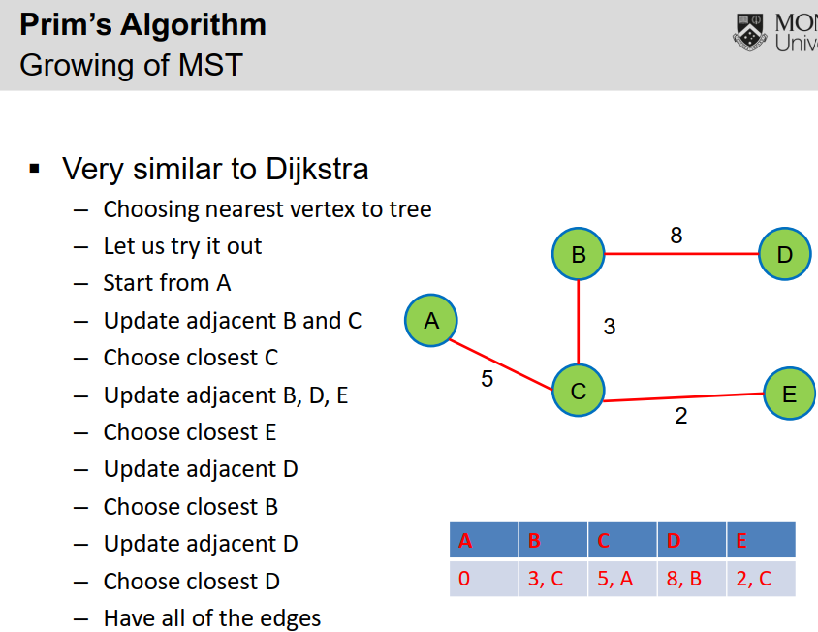

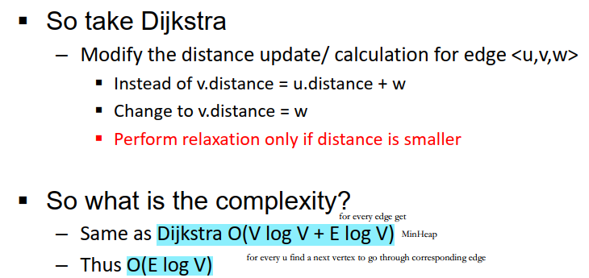

Prim’s don’t care about the cycle.

Prim’s always connect vertex closest (min edge) to the tree update the distance from target vertex to the tree (Dijkstra – overall distance from source, Prim’s – distance between any vertex in tree has connection to the target vertex, find the vertex has min distance, then connect the vertex with target

Since finding MST, cycle is avoided by checking whether the target vertex is already inside tree. Since between vertices in tree, there is only 1 connection, so no cycle is possible.

**Kruskal's**

- Disjoint set

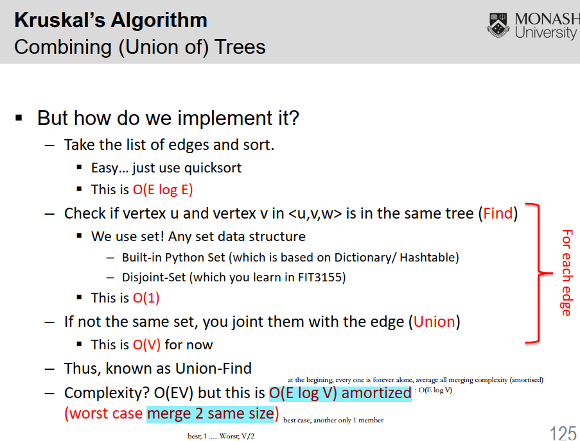

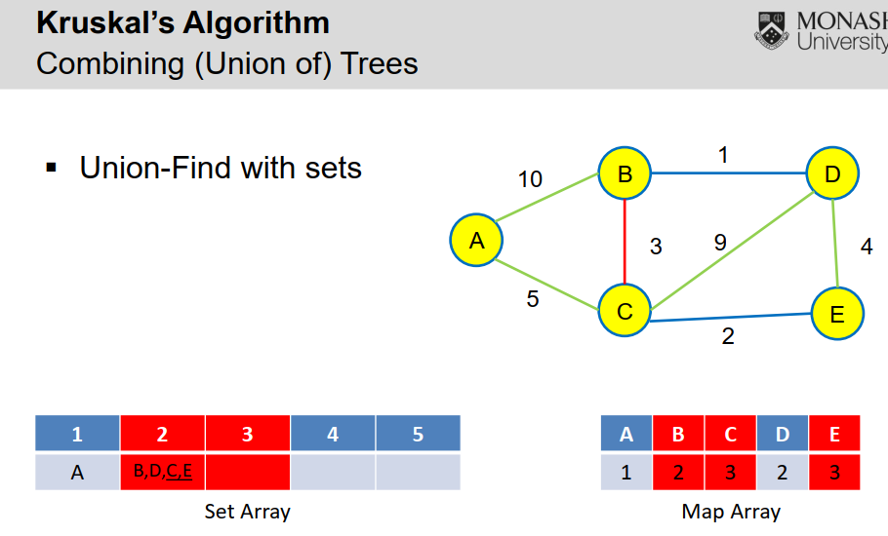

Initially 5 groups by index (1 – 5)

Group them by changing the value in the Map Array

To Merge Group 2 and 3

Need to connect members one by one in Group 3 to Group by looping through array (3 -> 2)

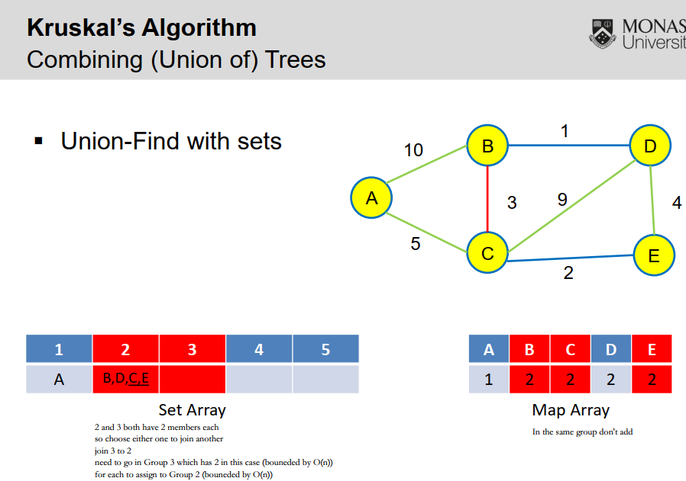

Union by Size

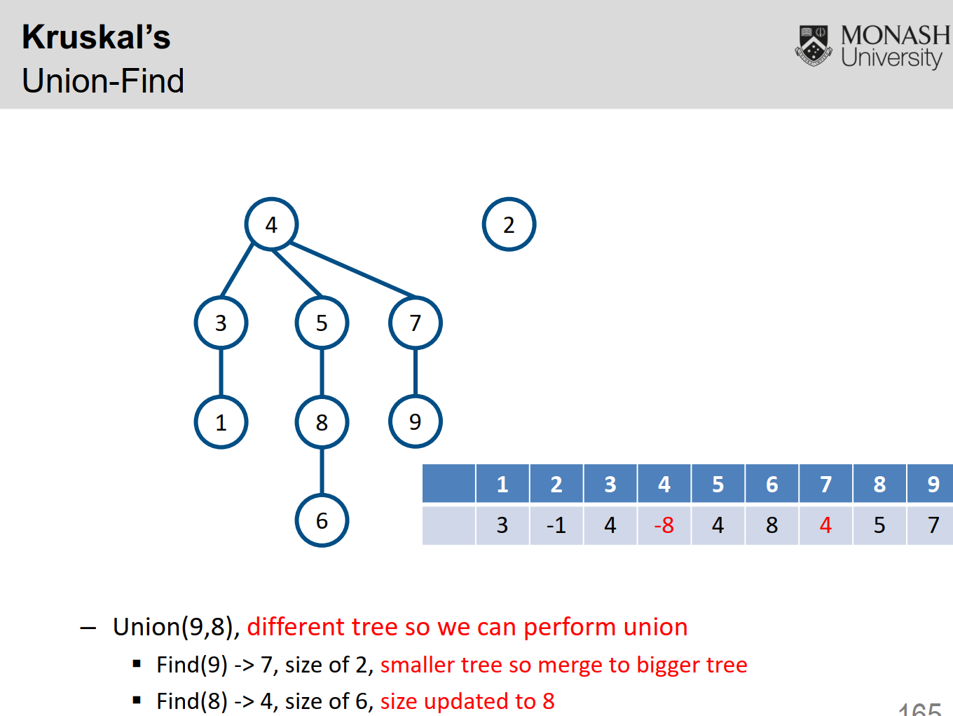

6 is the size (number of nodes) of the tree with root node 4 the tree has 6 nodes

4 is Group 4 (name after root node)

Need to trace alone the tree back to root (has negative value) with parent array for merging later

**Merging:**

merge = O(1)

merge root of one group with the root of another group,

node 4: -6 -> -8, node 7: -2 -> 4 (4 become its parent, by establishing edge)

- Parent Array for Union-Find

- parent-array

- this only tell you if vertices belong in the same MST

- this doesn't tell you if it is the edge

- if parent of u is v, it doesn't mean edge <u,v> is in MST

- why? merging is at root level

- but the vertices of the edge may be not at root

- Amortized complexity?

- Not examined but I can explain

- find() is fast

- you might need to perform path merging which is slow at times, but this ensures future find is fast

- union() is slow

Kruskl’s – Dijkstra on all vetices?

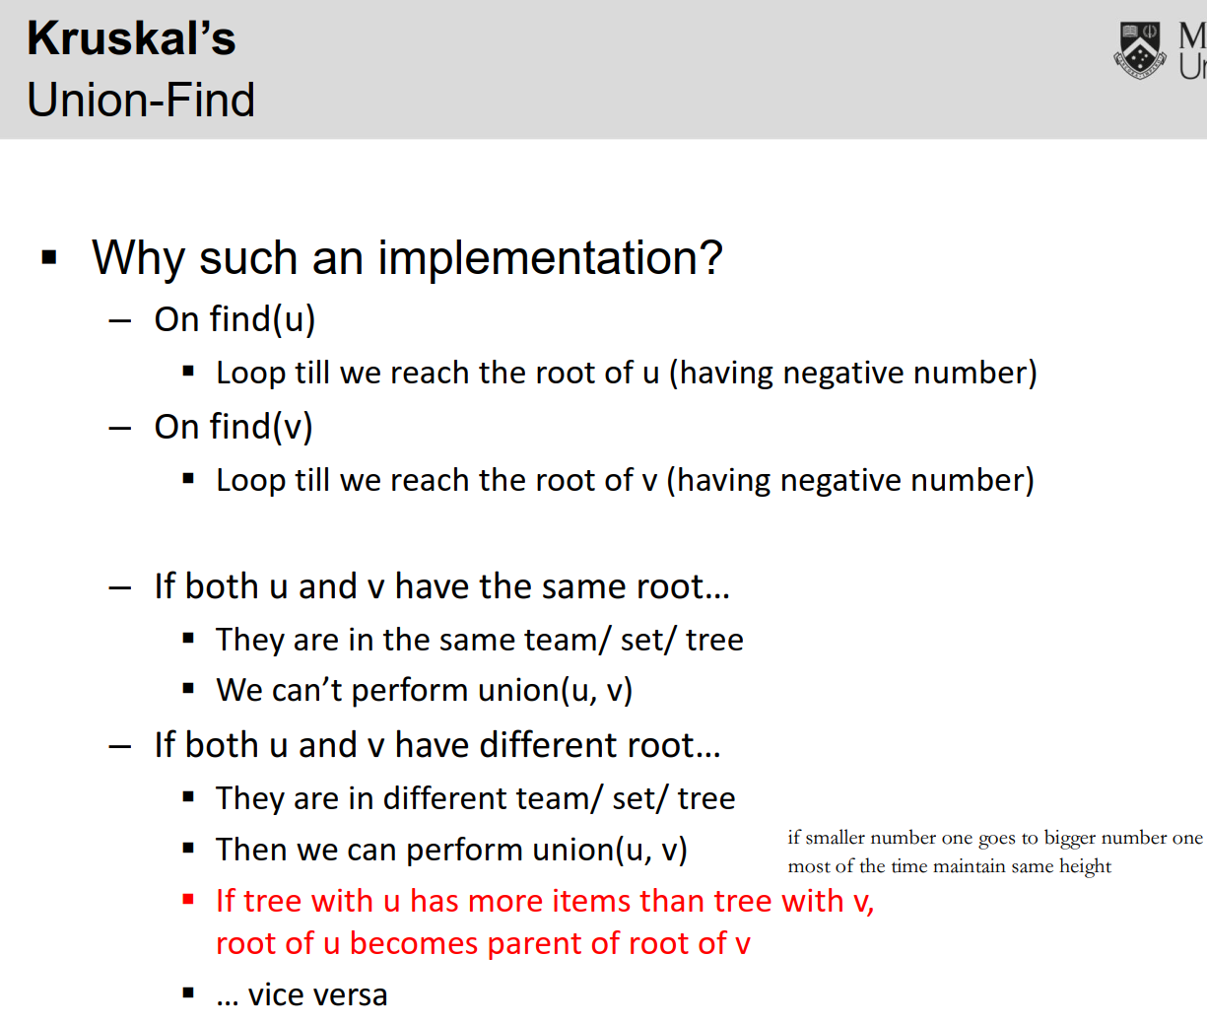

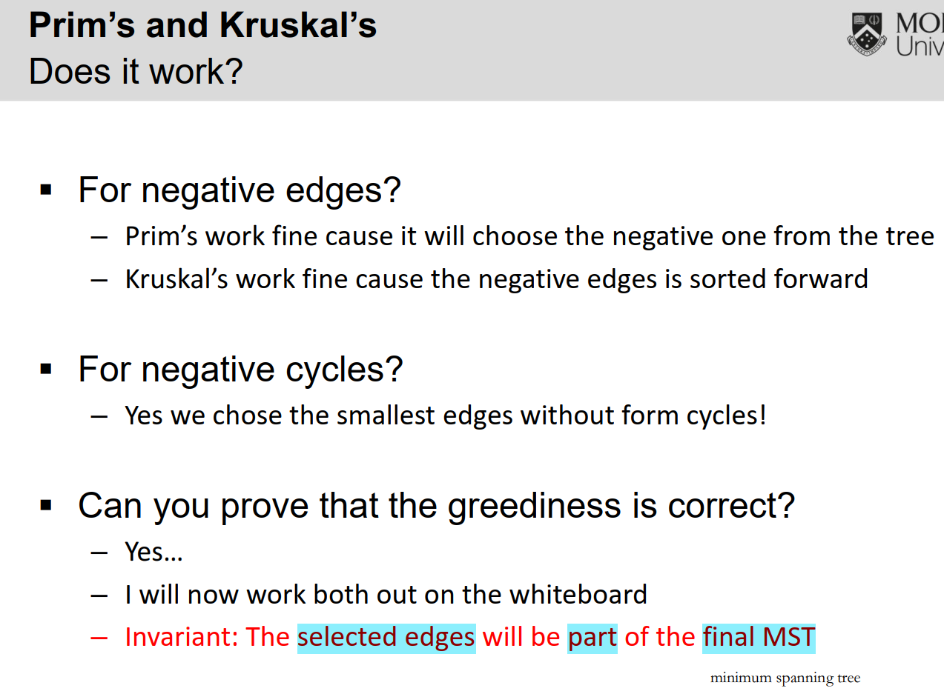

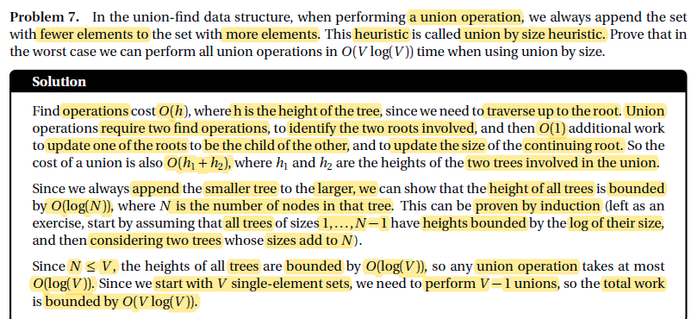

IF 5 vertices, then merge 1 by 1 to one tree would V – 1 time O(V)

Each time would need to traverse back to root since new added node is the

Leaf node (Olog(N))

Prove by contradiction;

Since Kruskal always merge two closest vertices (min edge in between) into a group which would eventually all these groups connect together to give a minimum spanning tree by (Union by Size) which would connect a root of smaller group of vertices to the root of bigger group. Prove by Contradiction (Prim’s would only connect the min-edge vertex due to Minheap, Kruskal’s would sort the edges in advanced, so always group u,v in that edge together if u and v in different group (initially each vertex has a group with name of their id as a index stored in an array.

Handle negatively-weighted edge

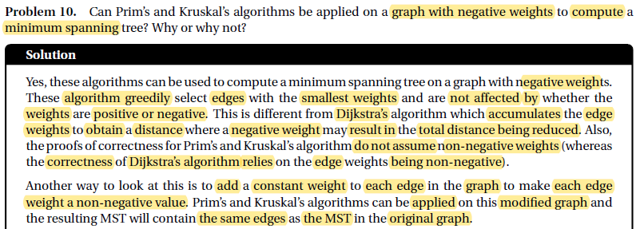

W7

Bellman-Ford (BF)

- Concept

- Dynamic Programming

- Overlapping subproblems: Number of edges

- Optimal subsolution: Shortest distance from source to vertex

- this allows you to just add 1 more edge

- How to backtrack?

- How to know if there is a negative cycle?

- if V-th column < V-1-th column

- Early termination

- Possible? Yes

- How? when 2 column (adjacent) is the same

- optimization

- do you need a matrix of V * (V+1)? NO

- because you only need the 2 column

- if 2 column is the same, you can terminate earlier

- because any additional loop wont change the value

- do you need 2 columnn? NO

- you can in change inplace of the array with only need 1 columnn or by keeping in vertex

- faster, you can terminate earlier

- reach convergence earlier

- worst case? V-times

- why? do not converge. why? if u have negative cycle, the value keep on becoming smaller and smaller

- ordering of edges to be relaxed matters

- different order give different results until convergence

Fundamentals of Bellman-Ford algorithm

- Able to find the shortest distance from the source with a graph that has negative weights

- Considers all edges V times to find shortest distance

- No shortest distance if there’s a negative cycle because it’ll loop forever

- Loop V-1 times as it’s the max amount of jumps without cycles in graphs to find shortest distance

- Last loop of loop V is to determine if there’s a negative cycle. If there is a difference between the array built in V-1’s iteration and V’s iteration, then there’s a negative cycle

- Time Complexity: O(VE), where V is number of vertices and E is number of edges

- Space Complexity: O(V), using the one column approach(always use this!)

2021 Sem 1 Question 17,18 and 19







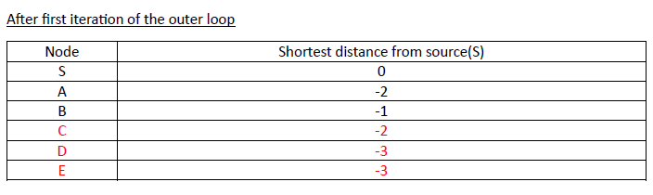



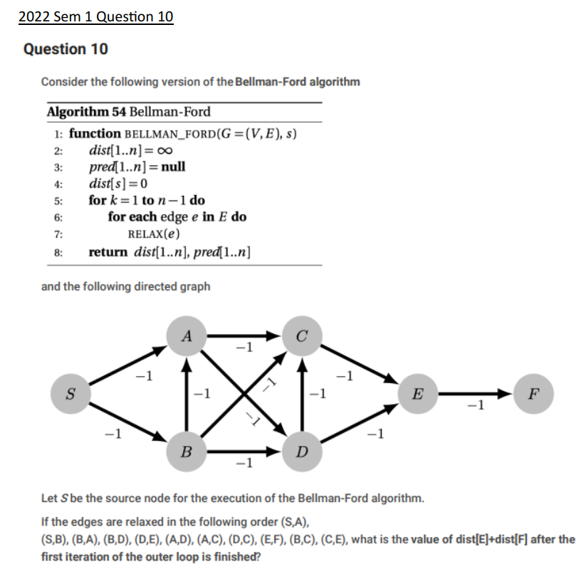

|  |  |
| --- | --- |
| Node | Shortest distance from source(S) |
| S | 0 |
| A | -2 |
| B | -1 |
| C | -4 |
| D | -3 |
| E | -5 |
| F | -4 |

Answer: -9

Floyd-Warshall (FW)

- Concept

- Dynamic Programming

- Overlapping subproblems: a->c, we have a->b and b->c

- Optimal subsolution: a->b shortest is known, and b->c shortest is knownn

Fundamentals of Floyd-Warshall algorithm

- Find **All-Pairs** shortest distance

- Builds on the transitive closure property: If A -> B and B -> C, then A -> C

- Able to detect negative cycles easily in a graph

- Time Complexity: O(V3), where V is the number of vertices

- Space Complexity: O(V2), where V is the number of vertices

- Faster than Dijkstra and Bellman-Ford for All-Pairs shortest distance because those

algorithms need to be ran multiple times. Finding All-Pairs shortest distance for Dijkstra is

O(V3 log V) and for Bellman-Ford is O(V4)

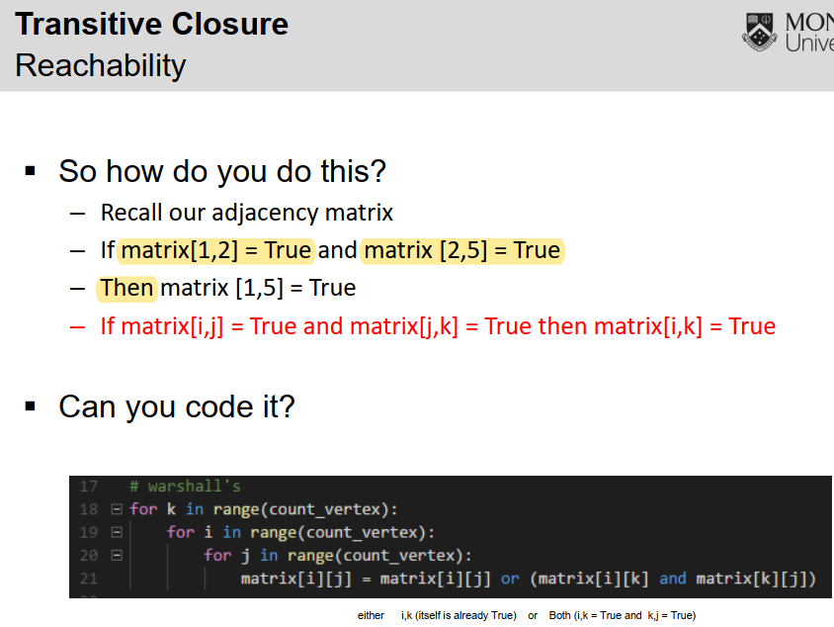

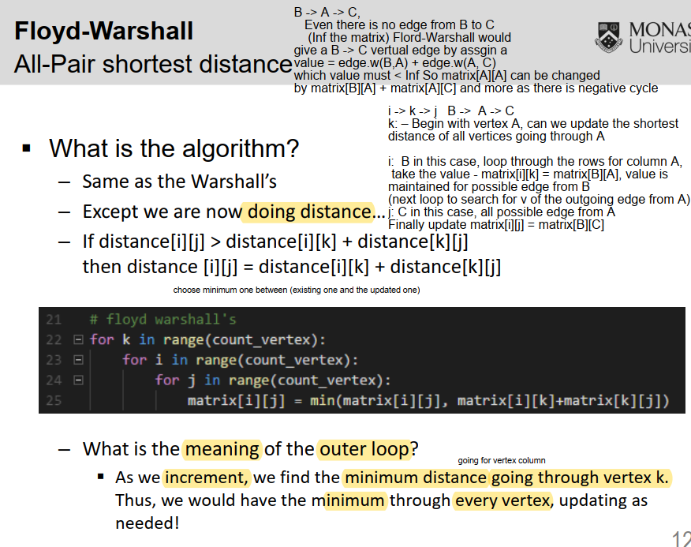

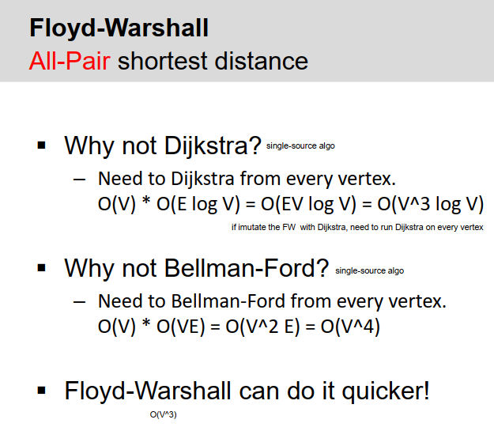

- How to backtrack?

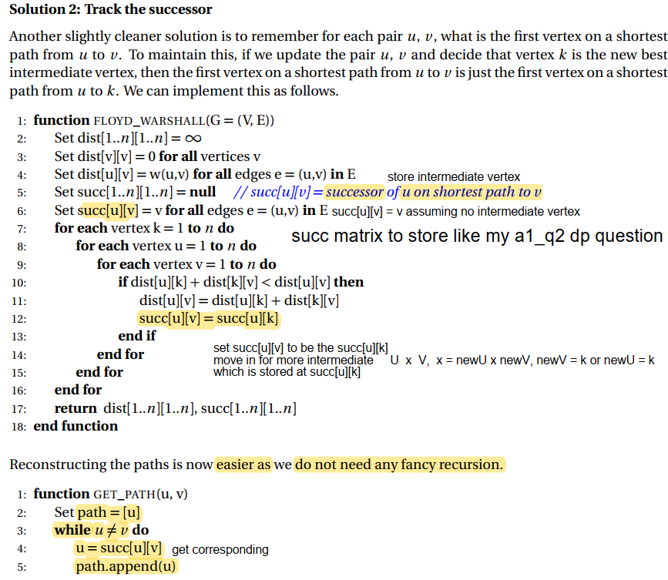



Path would only at most has k vertices

If succ[u][k] has intermediate, then it become new succ[u][v] and store

Succ[u][k], where k is the intermediate vertex otherwise v is stored in

Succ[u][v]

In GET_PATH(u,v)

u is updated by the succ[u][v] which is v

if there is intermediate between u, v, then succ[u][v] give k

u = k

path.append u (k)

path = [u,k]

succ[k][v] which store k_k (intermediate between k and v)

until no intermediate

path.append(v)

- remember the k (intermediate)

- a->b, b->c... we backtrack a->k, k->b and b->x and x->c

- repear each side

- How to know if there is a negative cycle

Diagonal values has negative, terminate immediately

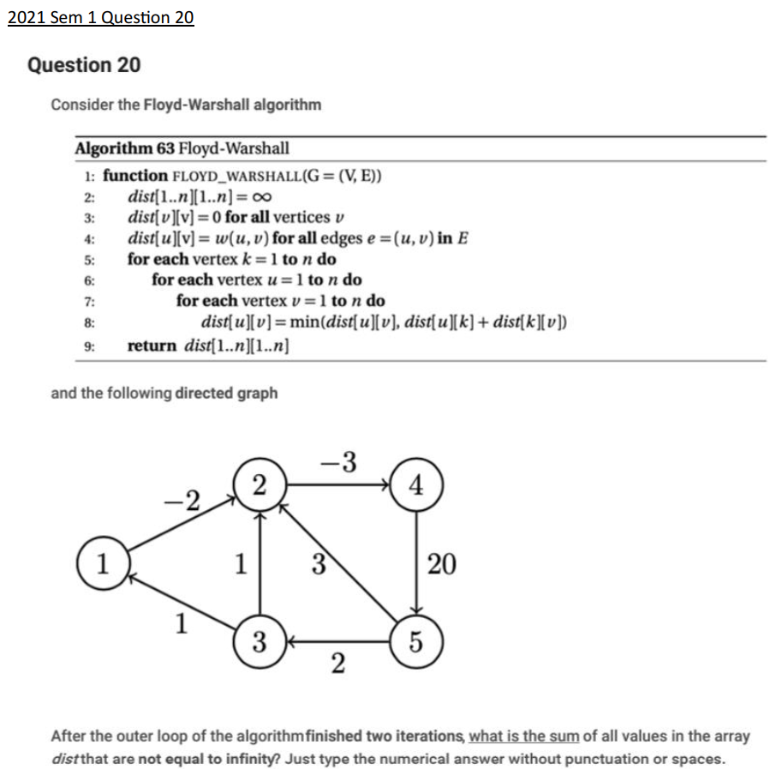

|  |  |  |  |  |  |
| --- | --- | --- | --- | --- | --- |
|  | 1 | 2 | 3 | 4 | 5 |
| 1 | 0 | -2 | INF | INF | INF |
| 2 | -3 | 0 |  | -3 |  |
| 3 | 1 | 1 | 0 |  |  |
| 4 |  |  |  | 0 | 20 |
| 5 |  | 3 | 2 |  | 0 |

Processing when k =1

Node 1 is intermediate

I -> k -> j

1 -> 1 -> 1 = 0 + 0 = 0

1 -> 1 -> 2 = 0 + -2 = -2

3 -> 1 -> 2 = 1 + -2 = -1

After first outer loop

|  |  |  |  |  |  |
| --- | --- | --- | --- | --- | --- |
|  | 1 | 2 | 3 | 4 | 5 |
| 1 | 0 | -2 | INF | INF | INF |
| 2 | Inf | 0 |  | -3 |  |
| 3 | 1 | -1 | 0 |  |  |
| 4 |  |  |  | 0 | 20 |
| 5 |  | 3 | 2 |  | 0 |

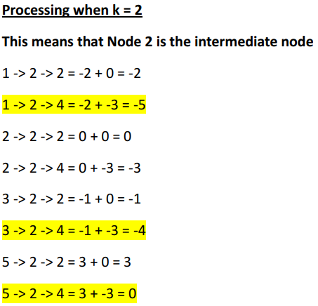

After second outer loop

|  |  |  |  |  |  |
| --- | --- | --- | --- | --- | --- |
|  | 1 | 2 | 3 | 4 | 5 |
| 1 | 0 | -2 | INF | -5 | INF |
| 2 | inf | 0 |  | -3 |  |
| 3 | 1 | -1 | 0 | -4 |  |
| 4 |  |  |  | 0 | 20 |
| 5 |  | 3 | 2 | 0 | 0 |

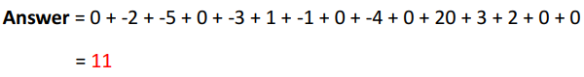



.

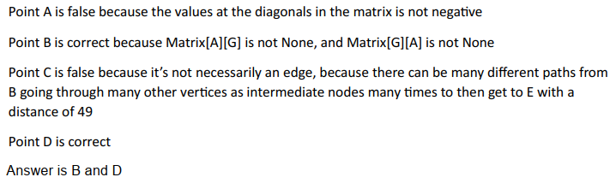

W8

## Week10 Sanity Check

Flow Network

- What is it?

- Directed

- Positive weight

- Capacity?

- Flow? initialize to 0

- Source -> Vertex **without incoming edges, generates flow**

- Target -> Vertex **without outgoing edges, collects flow**

- Edges -> The max amount of information that can be passed through(capacity)

- Flow -> How much information is currently passing through

- Flow Constraint Property -> Flow **CANNOT** be more than the capacity of an edge

- Flow Conservation Property -> **Incoming Flow == Outgoing Flow,** except for source and target

Residual Network

- Also known as potential network

- Forward edge?

- potential

- Backward/ reverse edge?

- undo

- Ford-Fulkerson

- Traversal

- source to sink

- Path augmentation

- using the traversed path from source to sink

- complexity O(F E) ~ O(V E^2)

**Maximum Flow Problem**

1) Find total flow -> Identify total flow flowing out from source and flowing in to target(it will always be the same)

2) We want to find the maximum flow possible while adhering to the two properties stated previously

3) To tackle this, we run Ford-Fulkerson method

**Ford-Fulkerson method**

- Residual Network -> Graph that contains only residual edges and reversible edges

- Residual/Forward Edge -> Remaining capacity of a given edge

- Reversible/Backward Edge -> Flow that can be cancelled

- We find maximum flow using path augmentation

- Sum if multiple residual/reversible edge pointing to same direction,

such sum equals edge capacity(this unit only works with simple graphs)

- Initialize Residual Network -> O(E)

- Path Augmentation -> O(V+E) because we are using BFS/DFS to find path and augment

- Whole Process -> O(F) where F is the flow, as we keep iterating until we found the maximum flow possible

- Total -> **O(FE)**

Min-Cut Max-Flow

**Cut**

- Splitting / Cutting our network flow into two sections

- First section has the source vertex included,

- second section has the target vertex included

- Capacity of a cut -> Capacity of outgoing edges from the cut

- Flow of a cut -> Flow of outgoing edges – Flow of incoming edges

**- Flow of cut <= Capacity of cut**

**Min-Cut Max-Flow theorem**

**- Flow of cut == Flow of network**

- Capacity of min-cut = max-flow of a network

- Ford-Fulkerson terminates when there is a cut that meets the requirement of:

1) Flow of each outgoing edge == Capacity of cutted corresponding edge (no residual edges)

2)Flow of each incoming edge to cut is 0 (no reverse edge)

**Easiest way to find that cut is to**

**find all reachable vertices from the source vertex in completed residual network.**

**If flow = capacity => not remaining capacity => no outgoing edge**

**All the reachable vertices from the source vertex are placed in the first section that has the source vertex included**

**the other vertices will be placed in the section that has the target vertex included.**

2022 Semester 1 Question 13



The vertices are S and A

Application with Biparttite Matching

- Problem statement

- Components

- Source

- Set1

- Set2

- Sink

- The edges that connect them!

- source to set1, what capacity?

- set 1 to set 2

- how many edge from a node to another

- what capacity?

- set2 to sink, what capcacity?

W9

Circulation with Demand

**Circulation with Demands**

- Instead of Flow Conservation property, we replace it with **Demand Constraint** property

- A demand constraint diagram does not have source/target vertex

The vertex initially has demand which decide how much to hold and flow

If -3, there is in total 3 flow to flow out/outgoing flow

If, get 1 incoming flow, then need to flow 1 more out

- What is a circulation?

- How does it differ from what you have learnt above?

- no source, no sink

Demand

- What is a demand?

- Positive demand

- Negative demand

- Incoming flow (V) – Outgoing flow(V) = Demand(V)

- How do you resolve demand?

- make source

- make sink

- Is a circulation feasible?

**Steps for checking whether the demand constraint diagram is feasible or not**

1) Create source vertex

2) Link source vertex to all vertices with negative demands

3) The edges of the source vertex to vertices with negative demands should have the weight equivalent to the demand itself

4) Create target vertex

5) Link all vertices with positive demands to target vertex

6) The edges of the vertices with positive demands to target vertex should have the weight equivalent to the demand itself

7) Run Ford-Fulkerson as usual

**The trick to identifying whether a demand constraint diagram is not feasible quickly**

- If the sum of the demand of all vertices are not equivalent to 0,

GUARANTEED to be not feasible!

- If the sum of the demand of all vertices are equivalent to 0, NOT GUARANTEED to be feasible, you still need to check using the steps as mentioned above

**How to know if the demand constraint diagram is feasible?**

1) The flow flowing from the source vertex is equivalent to the flow flowing into the target vertex

2) The flow flowing out from the source vertex and into the target vertex must be maximised(flow == capacity)

Lower-Bound

- What is a lower-bound?

- lower bound / flow / constraint

- what does it mean?

- How do you resolve this?

- minus incoming

- plus outgoing

**The inclusion of lower-bounds**

- Instead of 0 <= Flow <= Capacity, each edge is now ( lower-bounds/Flow/Capacity )

- Only one layer of preprocessing, and then same steps as circulation with demands without any lower bounds

So when there is minimum flow

1. Initial Demand(V) – incoming minimum flow + outgoing minimum flow = New Demand(V)

- Transform the diagram by adjusting the demand of each vertex and the

2. weight of the edges are now (capacity – lower bounds)

3. add source and sink with the edge of remaining capacity

If -3, there is in total 3 flow to flow out/outgoing flow

If, get 1 incoming minimum flow, then need to flow 1 more out -3 -> -4

If demand: 3 (3 flow to hold), 3 -> 2, since 2 flow to hold

If, there is 1 outgoing minimum flow already, the demand from -3 -> -2, since 1 job has been done already, only 2 more to flow out

- The question is whether the demand constraint diagram is feasible or not

- Once diagram is transformed, use the transformed diagram and repeat as usual in what was discussed previously to find out whether the demand constraint diagram is feasible or not

W10

Hash Table

Linear Probe -> Primary clustering (No space different hash values in hash table)

Quadratic Probe -> Secondary clustering (has space between different hash values, but has collision between same hash values due to collision)

AVL Tree

Ian’s way, Read Tutorial notebook

W11

# Week11 Sanity Check

- Node

- key is the letter

- payload

- can save annyhting think is important

- dont abuse it, it is inefficient

- payload can be updated

- children

- a...z = 26

- end or $ = 1

- indicate the word

- "abcd" "ab"

- space = O(X) + O(26) = O(1) if X is constant

- Insert

- insert(string[:], idx)

- a word with M length

- O(M) time

- Search

- same as insert with subtle differences

- a word with M length

- O(M) time

- Traversal

- is only 1 way

- inorder

- preorder

- postorder

- THEY ARE ALL THE SAME

- time = O(NM) because u traverse NM nodes

- complexity

- space complexity of a trie:

- N words

- M is the longest word

- O(NM) nodes

- but each node O(1)

- therefore total space of a trie is O(NM)

Suffix Trie

- i want a suffix trie

- i have M suffixes

- longest suffix is M

- O(M^2) space

Suffix Tree

- Why is it needed?

- reduce number of nodes

- have better space complexity

- using [start,end]

- What is the complexity

- O(M) space

Application of Trie

- Normal Trie aka prefix trie

- Suffix Trie/ suffix tree

- substring

- prefix of a suffix

- all suffixes are in suffix trie

- traversing down is prefix

- therefore prefix of a suffix

- suffix of a prefix

- longest repeating substring

- suffix array

**Trie**

Fundamentals

- A data structure to store strings efficiently

- Organize strings according to characters

- Height of the trie will be the length of the longest string

- A terminal character is always added to denote the end of a string

- Allows us to efficiently search whether a string exists or not in the trie

Search -> Worst case: O(M), where M is the length of the search string

Best case: O(1) when the first character isn’t found within the trie

Sorting -> O(MN) where M is the length of the string and N is the number of words

**Suffix Trie**

What are suffixes?

- Sequence of characters that is appended to the end of a string

- The suffixes of the string “GLHF” is:

1) “GLHF”

2) “LHF”

3) “HF”

4) “F”

Fundamentals

- It is a trie that stores all suffixes of a string

- Many applications such as finding substring, longest repeated substring etc…

Complexity

Time Complexity -> O(N2), where N is the length of the string (N path for N characters)

Space Complexity -> O(N2), where N is the length of the string

**Suffix Tree**

Fundamentals

- It is basically a compressed suffix trie

- Good to learn this because it will be extremely crucial in FIT3155 (Ukkonen’s Algorithm)



Complexity

Time Complexity -> O(N2), where N is the length of the string

Space Complexity

Complexity

Time Complexity -> O(N2), where N is the length of the string

Space Complexity -> O(N), where N is the length of the string

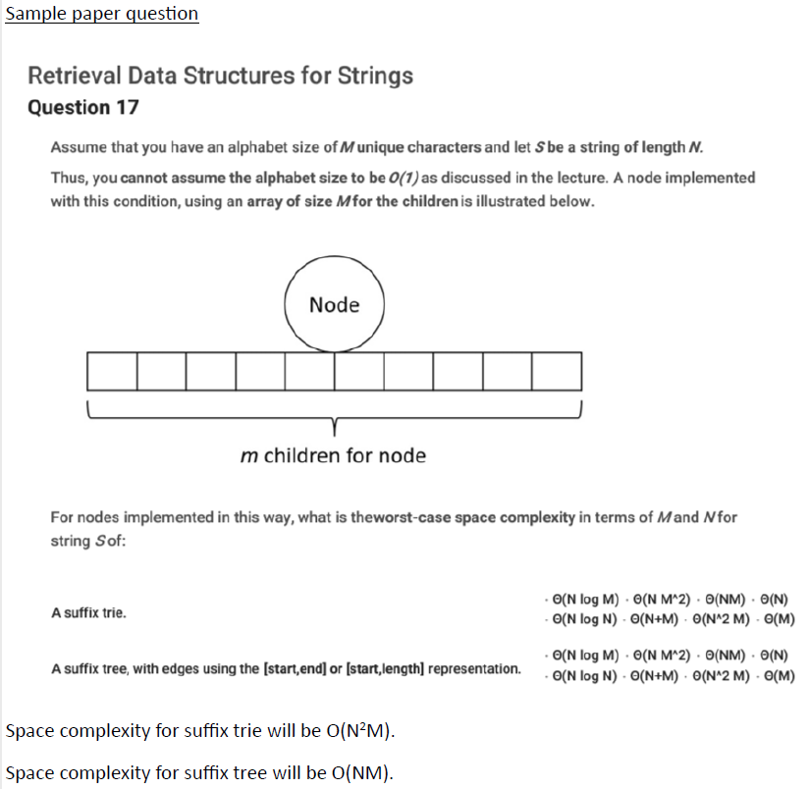

Normal suffix trie is already (N^2)

Each Node has m children = (N^2M)

Normal suffix tree is (N) => (NM)